CpE 487 Digital Design Lab
Lab 2: Four Digit Hex Counter
- Implementing the Counter
In Lab1, we built a single-digit (4-bit) hex counter that displayed its value on one of the 7-segment displays. In this lab, we will extend our design to create a four digit (16-bit) counter that will display its value using all four 7-segment displays on the Nexys2 board.
1.1 Time Multiplexing the Displays
The first issue we have to deal with is how to display 4 different digits on the 7-segment displays if they all share the same cathode lines (CA~CG). We do this my time multiplexing the displays; that is, we only drive one display at a time. Suppose we turn on display0 for a few milliseconds by enabling its common anode AN0 and decoding count (0~3) to drive the cathode lines. Then we switch to display1 for a few milliseconds by turning off AN0, turning on AN1 and decoding count(4~7) to drive the cathode lines. We then shift to display2 for a few milliseconds and then finally display3 for a few milliseconds, after which we go back and start again at display0. Each digit is this illuminated only one quarter of the time, but if we do this multiplexing fast enough (at least 60 complete cycles per second), it will appear to our eye as if all four displays are continuously illuminated – each with their own 4-bits of information. Timing waveforms for this technique are shown in Figure 1.
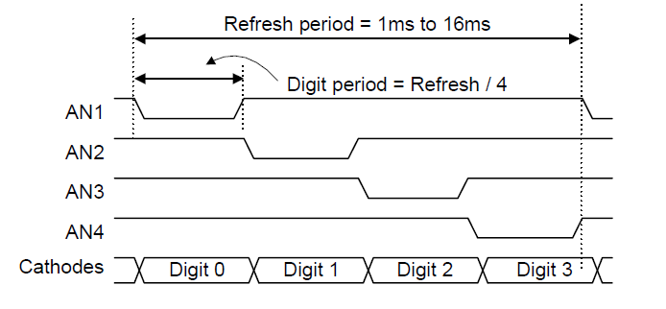
Figure 1 Four Digit 7-segment Display Timing Diagram

1.2 VHDL Design
- Open your Lab1 project hexcounter in the ISE WebPack software. Use FileCopy Project to make a copy of your project named hex4digit. Note that even ‘though we have created a new project, the ISE software still has the old project hexcounter open. So, close the old project hexcounter and open the new project hex4counter.
- Expand the hexcount hierarchy in the Hierarchy window and open up the source code to the counter module. Modify the counter module to generate a 16-bit count value using bits 23~38 of the binary counter as shown in Figure 2. We also create a second output mpx. This will be used to multiplex the four 7-segment displays. We drive mpx using binary counter bits 17-18. These will generate a 0-3 count sequence counting at a frequency of $50 MHz÷2^{17}≈381 Hz$. The sequence will repeat at a frequency of approx. $381÷4=95 Hz$ which is fast enough to eliminate any visual flicker in the 7-segment displays.
- Double-click Check Syntax in the Process window to make sure the counter module is free of syntax errors.
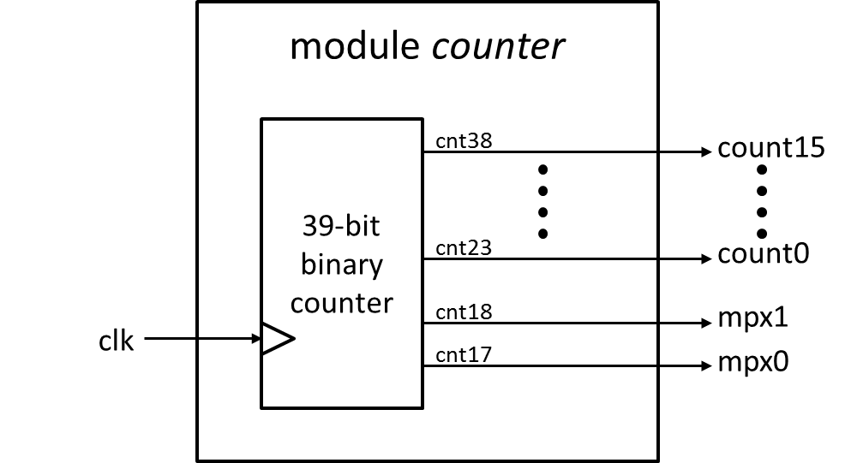
Figure 2 Modified counter module

- Now open the source code for the top level module hexcount. Modify the hexcount module to implement the structure shown in Figure 3. The mpx output from the new counter module now drives the dig input of the leddec module. The 2-bit mpx signal is also used to select which 4-bits of the 16-bit count output should be sent to the data input of the leddec module. You will need to add some code to the hexcount module to perform this data multiplexing operation.
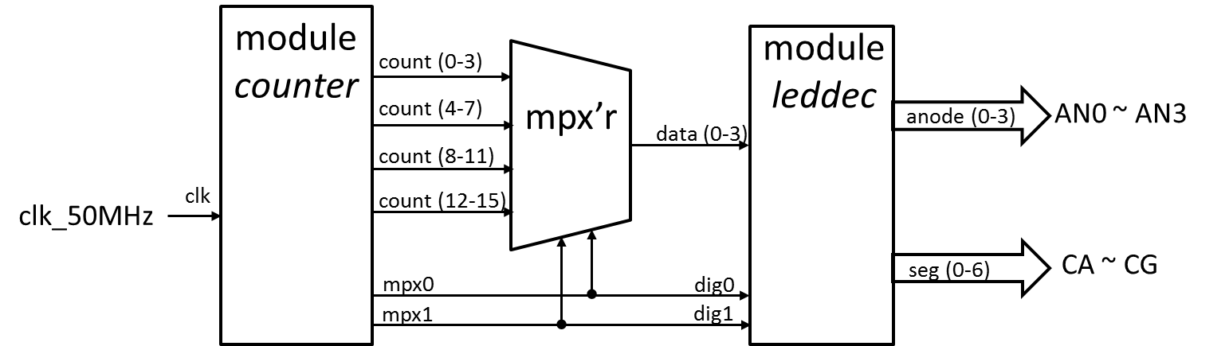
Figure 3 Modified hexcount module

1.3 Synthesize, Download & Run
Run the Synthesis process on the module hexcount to check for any VHDL design errors. Then run Impement Design and Generate Programming File. Once you have created the hexcount.bit configuration file, you can load it into the FPGA with the Adept software. Remember to browse to the correct project so that you download the new hexcount.bit – not the old one from Lab1.
- Storing Configuration Code in the Platform Flash
When we download the FPGA configuration (.bit) file directly into the FPGA, the configuration data is stored in SRAM on the FPGA device. This SRAM is erased whenever power is removed or the FPGA board is reset. Once you have completed a design, you may wish to store your configuration data in the Platform FLASH ROM so that your design will be loaded and executed directly on power-up. To do this, we need to create a .mcs file to program the Platform FLASH.
Highlight the hexcount module in the Hierarchy window. Expand the Configure Target Device command in the Process window and double click on Manage Configuration Project. An ISE iMPACT window will pop up as in Figure 4.
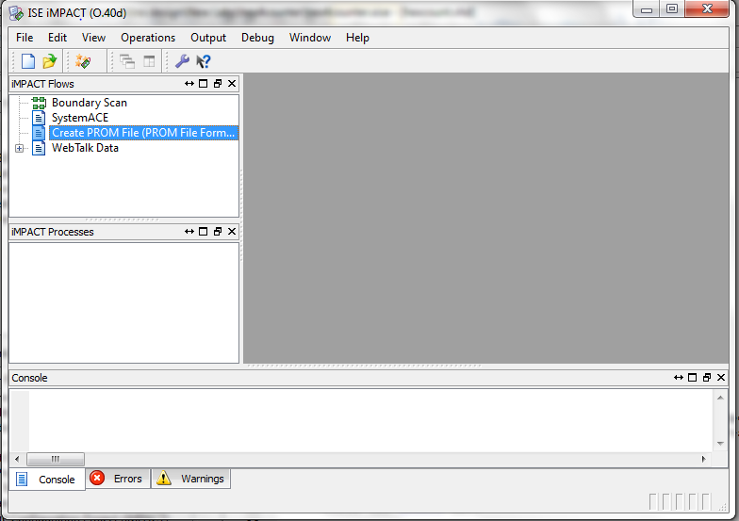
Figure 4 ISE Impact Window

Double click on Create PROM File in the iMPACT Flows window. This brings up the PROM File Formatter window.
Step 1: Select Xilinx Flash/PROM in the Storage Device Type and click the green arrow.
Step2: Select Platform Flash as the PROM Family and xcf04s as the Device. Click Add Storage Device and then click the green arrow.
Step 3: Enter hexcount as the Output File Name. Use the browser button to set the Output File Location to the current project (hex4counter) folder. The formatter window should now appear as in Figure 5.
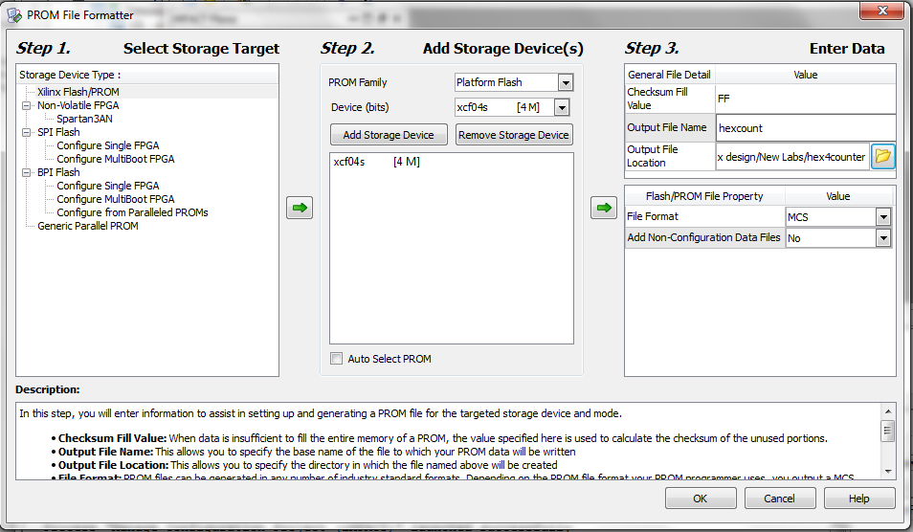
Figure 5 ISE Completed PROM File Formatter Window

Click OK at the bottom of the window. Click OK on the Add Device pop-up window and an Add Device browsing window appears. It should be pointing to your current project folder. Double click hexcount.bit. Another pop-up asks you if you want to add another device file. Select No and then click OK. The ISE impact Window should now appear as in Figure 6.
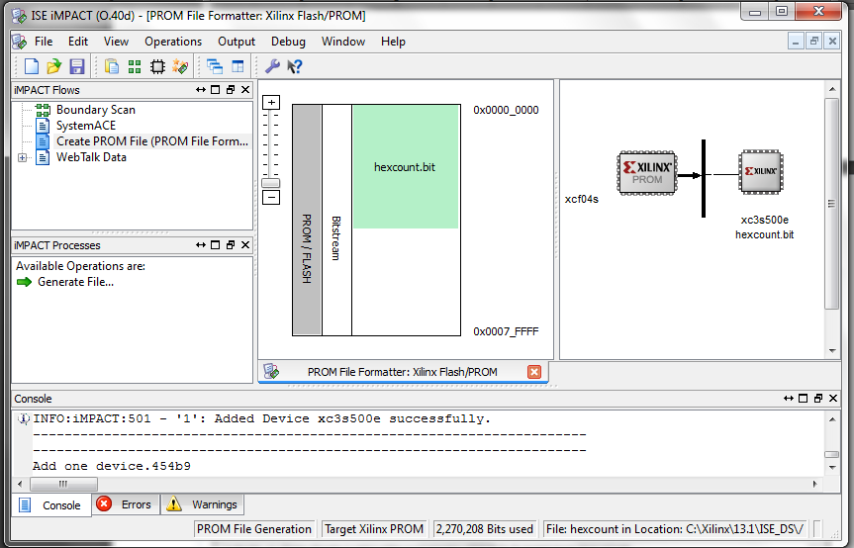
Figure 6 ISE Completed ISE impact Window
Double-click Generate File in the iMPACT Processes Window. This generates the hexcount.mcs file and gives you a blue “Generate Succeeded” pop-up when complete.
You can now use the Adept software to program the Platform Flash. Select the Config tab and use the Browse button on the PROM line to select the file hexcount.mcs. Click the Program button. It may take about one minute to complete the programming process. Once the programming is complete, push the reset button on the Nexys2 board. This will download your FPGA configuration from the Platform FLASH and begin executing four digit counter. Try turning the power off to your Nexys2 board. Turn it on again and your program should once again load and start running.

