CpE 487 Digital Design Lab
Lab 5: DAC Siren
- Introduction
In this lab, we will program the FPGA on the Nexys2 board to generate a wailing audio siren using a digital to analog converter (DAC). This will require us to format our digital audio sequence into a serial stream that can be used to drive an outboard DAC.
- DAC Interface
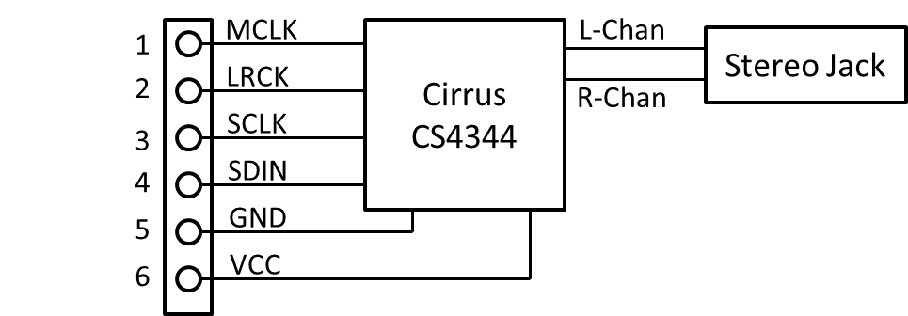
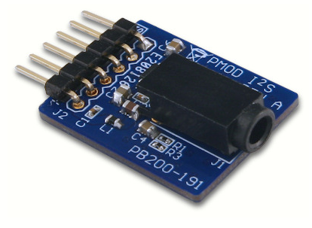
Figure 1 PModI²S 16-bit Stereo DAC Module
We will be using a 16-bit stereo Digital to Analog Converter module PmodI²S which plugs into one of the PMOD connectors on the Nexys2 board. The module and its connections are shown in Figure 1. The module uses a Cirrus CS4344 Stereo DAC chip. Documentation on the module and the chip can be found on the course website.

The DAC converts “left” and “right” 16-bit digital data streams into two analog left and right channel signals which can be used to drive a stereo speaker system. In order to minimize the number of I/O pins on the chip and the module, data is presented to the DAC in serial format. The DAC employs an oversampled Delta-Sigma Modulator to convert the digital data into analog format. The FPGA supplies three clocks to the DAC:
LRCK: This is the audio sampling clock – it sets the audio sampling rate. We will be using an audio sampling rate of 48,800 samples/second. When LRCK is low, left channel data is transferred into the DAC. When LRCK is high, right channel data is transferred.
SCLK: This is the serial clock used to transfer data into the DAC. Data is transferred on the rising edge of SCLK. Because there are two channels, each requiring 16-bits of data, SCLK runs at 32x the sampling clock. We will be using an SCLK frequency of 1.56 MHz.
MCLK: This is a high speed clock that is used to drive the on-chip oversampled delta-sigma modulator. It can be set anywhere from 500kHz to 50 MHz. In this lab, we will be using an oversampling ratio of 256, which means that MCLK must be 256x the sampling clock. We will be using an MCLK frequency of 12.5 MHz.
Figure 2 shows the required timing relationship between LRCK, SCLK and the serial data. The CS4344 uses a serial data standard known as I²S. Note that data is transferred MSBit first with the MSBit of each channel being transferred on the second rising edge of SCLK after LRCK changes from one channel to the other.
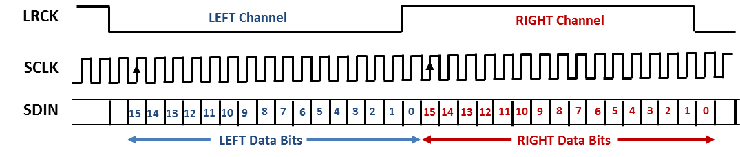
Figure 2 CS4344 I²S Data Format

- Hardware Setup
Plug the PmodI²S module into PMOD jack JA1 on the Nexys2 boards as shown in Figure 3. Note that the PmodI²S has only 6 pins whereas the jack JA1 has 12 sockets (2 rows of 6). Plug the module into the top row of sockets on JA1. Please be careful not to bend the pins on the PmodI²S module. Now connect the audio cable from your stereo speaker system into the audio jack on the PmodI²S module.
Figure 3 PmodI²L Module inserted in PMOD jack JA1

- Configuring the FPGA
4.1 Create a New Project
Use the Xilinx ISE software to create a new project named Siren using the same project settings as in Labs 1 and 2.
4.2 Add Source for “dac_if”
Create a new VHDL source module called dac_if and load the following source code into the edit window. Expand the Synthesize command in the Process window and run Check Syntax to verify that you have entered the code correctly.

library IEEE;
use IEEE.STD_LOGIC_1164.ALL;
use IEEE.NUMERIC_STD.ALL;

entity dac_if is
Port ( SCLK : in STD_LOGIC; -- serial clock (1.56 MHz)
L_start: in STD_LOGIC; -- strobe to load LEFT data
R_start: in STD_LOGIC; -- strobe to load RIGHT data
L_data : in SIGNED (15 downto 0); -- LEFT data (15-bit signed)
R_data : in SIGNED (15 downto 0); -- RIGHT data (15-bit signed)
SDATA : out STD_LOGIC); -- serial data stream to DAC
end dac_if;

architecture Behavioral of dac_if is

signal sreg: STD_LOGIC_VECTOR (15 downto 0); -- 16-bit shift register to do
-- parallel to serial conversion
begin

-- SREG is used to serially shift data out to DAC, MSBit first.
-- Left data is loaded into SREG on falling edge of SCLK when L_start is active.
-- Right data is loaded into SREG on falling edge of SCLK when R_start is active.
-- At other times, falling edge of SCLK causes REG to logically shift one bit left
-- Serial data to DAC is MSBit of SREG
dac_proc: process
begin
wait until falling_edge(SCLK);
if L_start = '1' then
sreg <= std_logic_vector (L_data); -- load LEFT data into SREG
elsif R_start = '1' then
sreg <= std_logic_vector (R_data); -- load RIGHT data into SREG
else sreg <= sreg(14 downto 0) & '0'; -- logically shift SREG one bit left
end if;
end process;

SDATA <= sreg(15); -- serial data to DAC is MSBit of SREG

end Behavioral;
_______________________________________________________________________________

This module takes 16-bit parallel stereo data and converts it to the serial format required by the digital to analog converter. When L_start is high, a 16-bit left channel data word is loaded into the 16-bit serial shift register SREG on the falling edge of SCLK. When L_start goes low, SCLK shifts the data out of SREG, MSBit first to the serial output SDATA at a rate of 1.56 Mb/s. Simlarly, when R_start goes high, right channel data is loaded into SREG and then shifted out to SDATA. Output data changes on the falling edge of SCLK, so that it is stable when the DAC is reading the data on the rising edge of SCLK.

4.2 Add Source for “tone”
Create a new VHDL source module called tone and load the following source code into the edit window. Expand the Synthesize command in the Process window and run Check Syntax to verify that you have entered the code correctly.

library IEEE;
use IEEE.STD_LOGIC_1164.ALL;
use IEEE.NUMERIC_STD.ALL;

-- Generates a 16-bit signed triangle wave sequence at a sampling rate determined
-- by input clk and with a frequency of (clk*pitch)/65,536
entity tone is
Port ( clk : in STD_LOGIC; -- 48.8 kHz audio sampling clock
pitch : in UNSIGNED (13 downto 0); -- frequency (in units of 0.745 Hz)
data : out SIGNED (15 downto 0)); -- signed triangle wave out
end tone;

architecture Behavioral of tone is

signal count: unsigned (15 downto 0); -- represents current phase of waveform
signal quad: std_logic_vector (1 downto 0); -- current quadrant of phase
signal index: signed (15 downto 0); -- index into current quadrant

begin

-- This process adds "pitch" to the current phase every sampling period. Generates
-- an unsigned 16-bit sawtooth waveform. Frequency is determined by pitch. For
-- example when pitch=1, then frequency will be 0.745 Hz. When pitch=16,384, frequency
-- will be 12.2 kHz.
cnt_pr: process
begin
wait until rising_edge(clk);
count <= count + pitch;
end process;

quad <= std_logic_vector (count (15 downto 14)); -- splits count range into 4 phases
index <= signed ("00" & count (13 downto 0)); -- 14-bit index into the current phase

-- This select statement converts an unsigned 16-bit sawtooth that ranges from 65,535
-- into a signed 12-bit triangle wave that ranges from -16,383 to +16,383

with quad select
data <= index when "00", -- 1st quadrant
16383 - index when "01", -- 2nd quadrant
0 - index when "10", -- 3rd quadrant
index - 16383 when others; -- 4th quadrant

end Behavioral; ______________________________________________________________________________

This module generates a signed triangular wave (a tone) at a sampling rate of 48.8 KHz. The frequency of the tone is determined by the input pitch. The process cnt_pr generates an unsigned sawtooth waveform count by incrementing a 16-bit counter pitch values every clock cycle. The frequency with which it traverses the whole 16-bit count range is thus proportional to pitch. The lowest possible tone frequency is obtained when pitch=1. It then takes 2¹⁶=65,536 cycles to traverse the range of the counter. The frequency is then 48.8kHz / 2¹⁶ ≈ 0.745 Hz. If pitch is set to 1000, the frequency would be 1000*0.745 Hz ≈745 Hz.

A select signal assignment statement is then used to convert the unsigned sawtooth count into a signed triangle wave. The sawtooth count is split up into 4 quadrants quad and an index value within the quadrant. The signals quad and index are used to generate a triangle wave as shown in Figure 4.
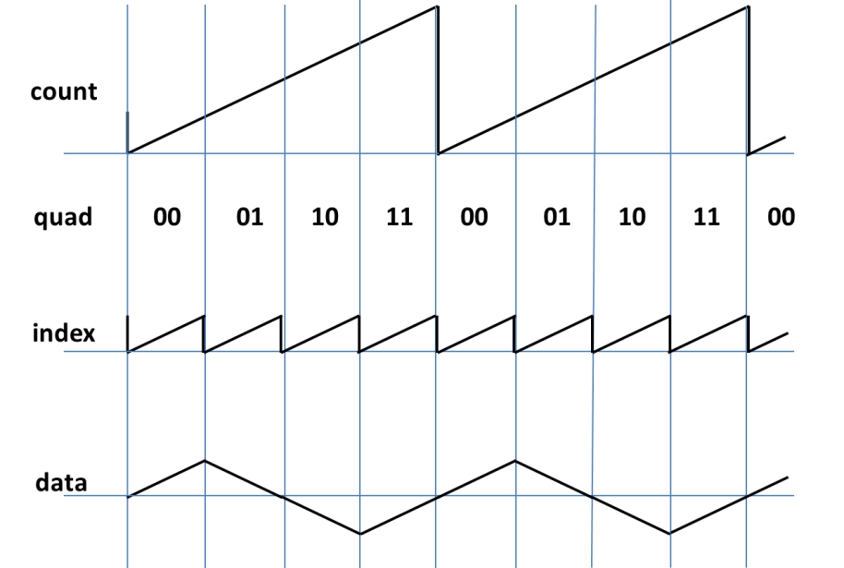
Figure 4 Conversion from 16-it unsigned sawtooth to 16-bit signed triangle waveform
4.3 Add Source for “wail”
Create a new VHDL source module called wail and load the following source code into the edit window. Expand the Synthesize command in the Process window and run Check Syntax to verify that you have entered the code correctly.

library IEEE;
use IEEE.STD_LOGIC_1164.ALL;
use IEEE.NUMERIC_STD.ALL;

-- Generates a "wailing siren" sound by instancing a "tone" module and modulating
-- the pitch of the tone. The pitch is increased until it reaches hi_pitch and then
-- decreased until it reaches lo_pitch and then increased again...etc.
entity wail is
Port ( lo_pitch : in UNSIGNED (13 downto 0); -- lowest pitch (in units of 0.745 Hz)
hi_pitch : in UNSIGNED (13 downto 0); -- highest pitch (in units of 0.745 Hz)
wspeed : in UNSIGNED (7 downto 0); -- speed of wail in pitch units/wclk
wclk : in STD_LOGIC; -- wailing clock (47.6 Hz)
audio_clk : in STD_LOGIC; -- audio sampling clock (48.8 kHz)
audio_data : out SIGNED (15 downto 0)); -- output audio sequence (wailing tone)
end wail;

architecture Behavioral of wail is

component tone is
Port ( clk : in STD_LOGIC;
pitch : in UNSIGNED (13 downto 0);
data : out SIGNED (15 downto 0));
end component;

signal curr_pitch: UNSIGNED (13 downto 0); -- current wailing pitch

begin

-- this process modulates the current pitch. It keep a variable updn to indicate
-- whether tome is currently rising or falling. Each wclk period it increments
-- (or decrements) the current pitch by wspeed. When it reaches hi_pitch, it
-- starts counting down. When it reaches lo_pitch, it starts counting up
wp: process
variable updn: std_logic;
begin
wait until rising_edge(wclk);
if curr_pitch >= hi_pitch then updn :='0'; -- check to see if still in range
elsif curr_pitch <= lo_pitch then updn := '1'; -- if not, adjust updn
end if;
if updn = '1' then curr_pitch <= curr_pitch + wspeed; -- modulate pitch according to
else curr_pitch <= curr_pitch - wspeed; -- current value of updn
end if;
end process;

tgen: tone port map( clk => audio_clk, -- instance a tone module
pitch => curr_pitch, -- use curr-pitch to modulate tone
data => audio_data);

end Behavioral;
______________________________________________________________________________

This module creates an instance of the module tone and then modulates the pitch up and down to produce a “wailing” siren. The inputs hi_pitch and lo_pitch define the upper and lower limits of the generated tone. The inputs wspeed and wclk determine how fast the pitch changes.

The wailing tone is generated by the process wp. This process is run on the rising edge of wclk. This is a slow clock (approx. 48 Hz.) Every wclk cycle, the current pitch is raised or lowered depending on the value of updn. When updn=’1’, the pitch rises. When updn=’0’, the pitch lowers. The input wspeed determines how much the pitch changes every wclk cycle. When the current pitch exceeds hi_pitch, updn is set to ‘0’ so that the pitch will start decreasing. Similarly, when the current pitch is lower than lo_pitch, updn is set to ‘1’ to start the tone rising again.

4.4 Add Source for top level “siren”
Create a new VHDL source module called siren and load the following source code into the edit window. Expand the Synthesize command in the Process window and run Check Syntax to verify that you have entered the code correctly.

library IEEE;
use IEEE.STD_LOGIC_1164.ALL;
use IEEE.NUMERIC_STD.ALL;

entity siren is
Port ( clk_50MHz : in STD_LOGIC; -- system clock (50 MHz)
dac_MCLK : out STD_LOGIC; -- outputs to PMODI2L DAC
dac_LRCK : out STD_LOGIC;
dac_SCLK : out STD_LOGIC;
dac_SDIN : out STD_LOGIC);
end siren;

architecture Behavioral of siren is

constant lo_tone: UNSIGNED (13 downto 0) := to_unsigned (344, 14); -- lower limit of siren = 256 Hz
constant hi_tone: UNSIGNED (13 downto 0) := to_unsigned (687, 14); -- upper limit of siren = 512 Hz
constant wail_speed: UNSIGNED (7 downto 0) := to_unsigned (8, 8); -- sets wailing speed

component dac_if is
Port ( SCLK : in STD_LOGIC;
L_start: in STD_LOGIC;
R_start: in STD_LOGIC;
L_data : in signed (15 downto 0);
R_data : in signed (15 downto 0);
SDATA : out STD_LOGIC);
end component;

component wail is
Port ( lo_pitch : in UNSIGNED (13 downto 0);
hi_pitch : in UNSIGNED (13 downto 0);
wspeed : in UNSIGNED (7 downto 0);
wclk : in STD_LOGIC;
audio_clk : in STD_LOGIC;
audio_data : out SIGNED (15 downto 0));
end component;

signal tcount: unsigned (19 downto 0) := (others=>'0'); -- timing counter
signal data_L, data_R: SIGNED (15 downto 0); -- 16-bit signed audio data
signal dac_load_L, dac_load_R: STD_LOGIC; -- timing pulses to load DAC shift reg.
signal slo_clk, sclk, audio_CLK: STD_LOGIC;

begin

-- this process sets up a 20 bit binary counter clocked at 50MHz. This is used
-- to generate all necessary timing signals. dac_load_L and dac_load_R are pulses
-- sent to dac_if to load parallel data into shift register for serial clocking
-- out to DAC
tim_pr: process
begin
wait until rising_edge(clk_50MHz);
if (tcount(9 downto 0) >= X"00F") and (tcount(9 downto 0) < X"02E") then
dac_load_L <= '1'; else dac_load_L <= '0';
end if;
if (tcount(9 downto 0) >= X"20F") and (tcount(9 downto 0) < X"22E") then
dac_load_R <= '1'; else dac_load_R <= '0';
end if;
tcount <= tcount+1;
end process;

dac_MCLK <= not tcount(1); -- DAC master clock (12.5 MHz)
audio_CLK <= tcount(9); -- audio sampling rate (48.8 kHz)
dac_LRCK <= audio_CLK; -- also sent to DAC as left/right clock
sclk <= tcount(4); -- serial data clock (1.56 MHz)
dac_SCLK <= sclk; -- also sent to DAC as SCLK
slo_clk <= tcount(19); -- clock to control wailing of tone (47.6 Hz)

dac: dac_if port map ( SCLK => sclk, -- instantiate parallel to serial DAC interface
L_start => dac_load_L,
R_start => dac_load_R,
L_data => data_L,
R_data => data_R,
SDATA => dac_SDIN );

w1: wail port map( lo_pitch => lo_tone, -- instantiate wailing siren
hi_pitch => hi_tone,
wspeed => wail_speed,
wclk => slo_clk,
audio_clk => audio_clk,
audio_data => data_L);

data_R <= data_L; -- duplicate data on right channel

end Behavioral; ______________________________________________________________________________

This is the top level that hooks it all together. The constants lo_tone, hi_tone and wail_speed define the parameters of the siren. The 20-bit timing counter tcount is used to generate all the necessary timing signals. The module wail is instanced to generate the 16-bit signed audio sequences data_L and data_R (the same data is sent to both channels). These sequences are then sent to an instance of dac_if to convert them to the required serial stream. Primary outputs of this top level module go directly to the DAC.

4.5 Synthesis and Implementation
Highlight the siren module in the Hierarchy window and execute the Synthesis command in the Process window.
Add an Implementation Constraint source file siren.ucf and enter the following data into the edit window:
____________________________________________________________________
NET "clk_50MHZ" LOC = B8;

NET "dac_SDIN" LOC = M15;
NET "dac_SCLK" LOC = L17;
NET "dac_LRCK" LOC = K12;
NET "dac_MCLK" LOC = L15;

NET "clk_50MHZ" TNM_NET = ck_50_net;
TIMESPEC TS_ck_50 = PERIOD "ck_50_net" 20 ns HIGH 50%; _____________________________________________________________________
Now highlight the siren module in the Hierarchy window and run Implement Design followed by Generate Programming File (don’t forget to change the FPGA Start-up Clock to be the JTAG Clock).
4.6 Download and Run
Use the Adept software to download your configuration file siren.bit and check out the result.
4.7 Now let’s make some changes …
Modify your VHDL code to do the following:
- Change the upper and lower pitch limits and also the wailing speed
- Modify the tone module to create a square wave instead of a triangle wave when the first push button (BTN0) is depressed. You will need to add this push button as an input to the top level siren module and pass its value down to the tone module. You can get the correct pin number for this push button from the Nexys2 Reference Manual. Note the difference in the quality of the tone when you switch to a square wave tone.
- Use the eight slide switches (SW0-SW7) on the Nexys2 board to set the wailing speed. You will need to add these as inputs to the top-level siren module. You can get the correct pin numbers for these switches from the Nexys2 Reference Manual.
- Try adding a second wail instance to drive the right audio channel. Use different high and low tone limits and wailing speed for the right channel.

