Portfolio Risk Management Software
CPE 322-S11 Final Report
Zixuan(Shin) Liu, Nirali Shah
May 4, 2011

I pledge my honor that I have abided by the Stevens Honor System

Table of Contents

Number | Title | Pages
1 | Introduction | 3-4
2 | Technical Information: Fundamental Description of the Design | 5-7
3 | Technical Information: Technical Description of the Design | 8
4 | Technical Information: Mathematical and Other Principles | 9
5 | Technical Information: Performance Expectations/Objectives | 10
6 | Background Information | 11-12
7 | Critical Evaluation of the Project | 13-14
8 | Summary | 15
9 | References | 16
10 | Bios (Vita) | 17-18

Introduction (Section 1)

Technology has revolutionized financial transactions. Now, one touch and you can probably conduct 10,000 trades in a minute. Arbitrage opportunities have always been fleeting and now with the advent of technology they disappear at the speed of light. This is where Financial software engineers come in. There are very few people who are equipped with a strong understanding of both finance and computer engineering. As you may have guessed, with low supply and high demand this field has a lot of opportunities. Stevens provides us the exceptional opportunity to collaborate with Quantitative Finance majors to work on an inter-disciplinary project.

The inception of this project comes from our strong interest in the subject of quantitative finance. For the 1st homework assignment, both of the group members wrote quantitative finance related proposals. Nirali proposed trading algorithm software while Zixuan proposed a risk management data aggregate reporter. Though these two proposals are not completely related, it brought two students together to write a cohesive financial engineering related software project. There is going be heavy modeling and simulations in the project and the CPE 345(Modeling and Simulation) will be particular useful for this project. Meanwhile, the group met with Prof. Calhoun who is the director of Stevens quantitative finance program to discuss possible collaborations with senior QF students and he said yes. Even though we only have 2 people in the team right now, more students will join next semester to form 4 or 5 people team.

The general idea of the project is software that can select an appropriate risk exposure level (benchmark) for a given portfolio according to different clients’ risk preferences. We want to start with a simple portfolio then different risk exposure level will be generated by different parameters (total cash, risk preference etc). Different risk models will be tested in the project. Those models will be obtained from some of the top quality papers in the field of risk management. There will be also improvement (from us) on these models, if possible. Most of the work for this project will be done in a proprietary risk analyzer provided by OneMarketData. . We are currently in talk with the company with the possibility of helping them improve the software itself.

The name of the company is called OneMarketData, here is the overivew of the company:
OneMarketData was founded in 2005 by Leonid Frants, Ph.D., who has spent more than 15 years building enterprise financial data management systems for statistical arbitrage, algorithmic trading and program trading departments of Goldman Sachs and Morgan Stanley.
As part of the global solution at Goldman Sachs, Dr. Frants built a comprehensive tick data solution as well as a reference data solution that linked and scrubbed all historical corporate actions, symbol changes, risk models, historical closing prices, and other reference and analytical market data to provide a unified repository to support the quantitative needs of a large financial institution.
Today, OneMarketData delivers comprehensive data management systems to industry leaders that span all asset classes and facets of finance. We focus on delivering high-quality solutions that are cost-effective and easy to use - empowering users to build queries and analyze data efficiently.
OneMarketData’s headquarter is in New York and it has offices in Hoboken, NJ.

Now there are two members in the group: Nirali Shah and Zixuan(Shin) Liu. However, we are looking to add more group members from the quantitative finance majors next year when the senior design cycle starts.

Technical Information (Section 2)

Section 2.1: Functional Description of the Design and its Components

Our current idea of the project is to develop a user interface where clients and construct simple portfolios and their risk preferences. Through the parameters they input the software can generate an appropriate maximum risk exposure (benchmark) of the portfolio. The results will be converted into cohesive presentation format if needed. The most critical component of the project will be the interface programming and mathematical modeling. Different risk evaluations techniques will use throughout the project.

The risk calculation interface will be based on OneTick from OneMarketData. The OneTick GUI gives users a graphical tool which can be used to view databases, construct, save and execute queries and view and save the results.

In order to perform the portfolio time risk analysis we have to use the tool to analyze the time series.

OneTick, queries time-series data using the event processing methodology. So, in general, OneTick’s queries are directed acyclic graphs, whose edges are streams of ticks and nodes are OneTick’s parameterized analytical event processors. This concept is shown in Figure below.

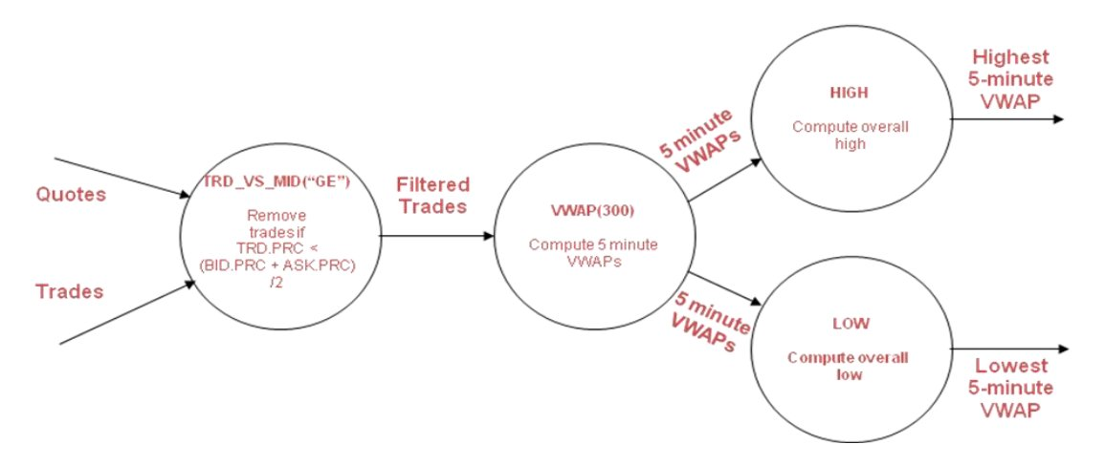
The query in figure 1, will take in a time-series of Quotes and Trades for a given set of symbols. For each symbol, the query will:

- Filter out trades where the trade price is greater than the current mid (calculated from the quote stream). Output a stream of filtered trades.
- Calculate a 5 minute VWAP on the filtered trade stream.
- This stream of 5 min VWAPs is then read by 2 separate processors which will output the overall high and low for the time-range defined at execution.

Below it is a screen shot of what a time series looks like in OneTick.
Our goal is to add some tools to the existing interface so the user can analyze varies portfolio risk factors based on our mathematical models.

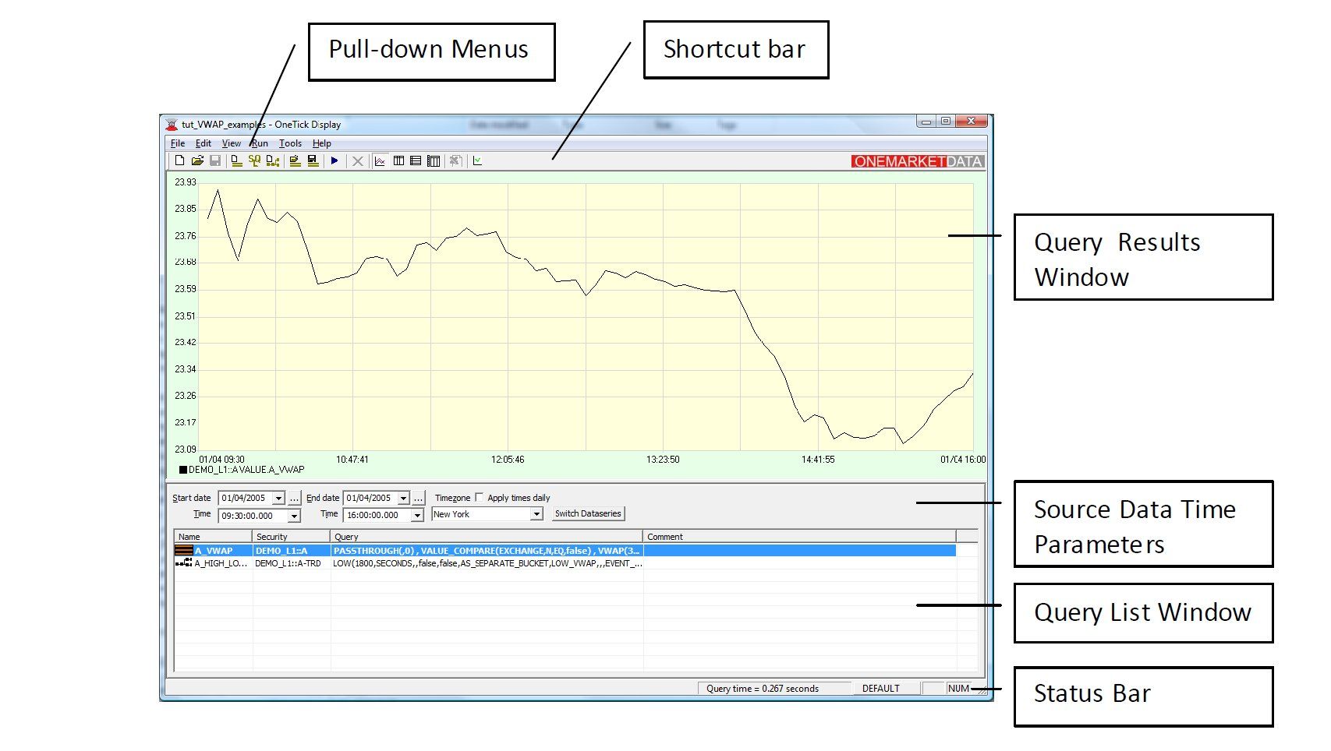

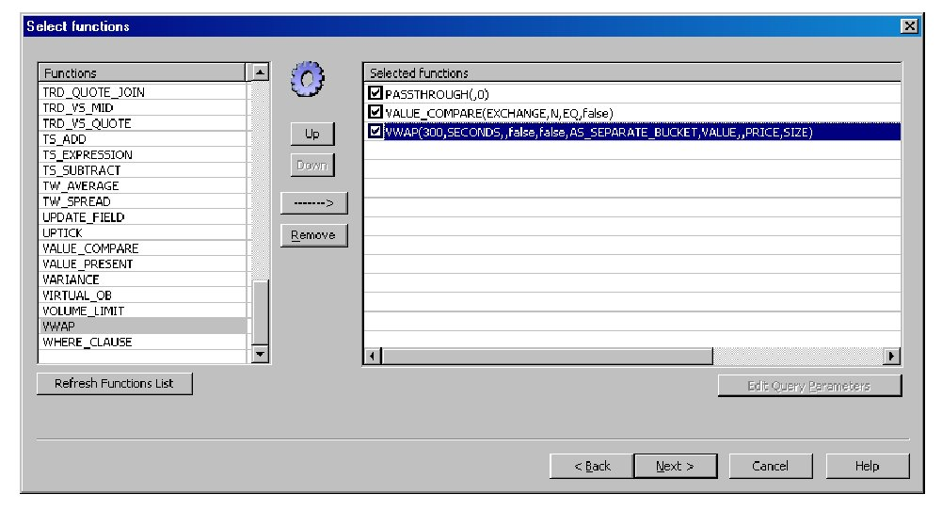

The project employs heavy quantitative components and simulations but after all it is still a software project so it will follow a typical software project development cycle. Please refer the chart as a simple software life development cycle:

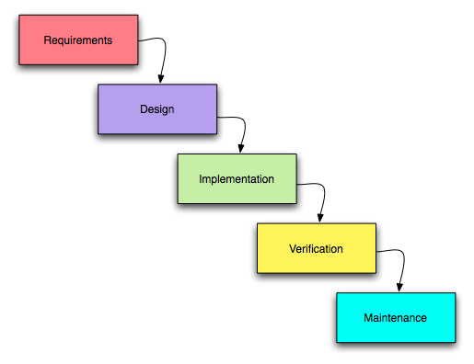
These 5 steps are crucial for the project. In other words, they are the milestones of the project:
- Requirement: We need to identify clients’ need and how they want the product to be like. A product which doesn’t meet clients’ requirements will soon be kicked out of the market. This requirement could be done by surveying some selected hedge fund and asset management firms.
- Design: This part involves heavy mathematical modeling. We need to investigate the theory behind every formula we use.
- Implementation: In this phase we need to translate mathematical language into programming languages.
- Verification: In this phase we need to work on debugging and and refine the requirements of the project.
- Maintenance: Make sure they system run smoothly as a whole.

Section 2.2: Technical Description of the Design and its Components

The design consists of two major components, programming and mathematical modeling. We don’t really deal with hardware in this project since this is most of a software project. To enable the risk analytic functions we want to use to calculate the risks we need to be able to program the interface.
At the very inception of the project, we thought about building an entire interface by ourselves. However, after careful considerations we think given the time constraints and the limitations of our knowledge. We decided to look for an existing interface. Fortunately, we found a financial time series analysis platform and with the help from Prof. German Creamer we got in touch with the company. So now we are able to leverage the platform. What’s more, the funding issue is also solved because our project will improve the current existing system which also fits the technogenesis spirit of the school.
For the mathematical modeling, we are going to try some simple mathematical model at this stage. In general, by using our function users can diversify their portfolio according their different risk preferences. For the mathematical modeling details please see sec 2.3.

Section 2.3: Mathematical or Other Principles Embedded in the Project

Here is the definition of a simple portfolio .We assume that E [|Rj |] < ∞ for all j = 1, . . . , n. Our objective is to shape the distribution of the total return rate on the investment. Denoting by x1, x2, . . . , xn the fractions of the initial capital invested in assets 1, 2, . . . , n we derive the formula for the total return rate:
R(x) = R1x1 + R2x2 +· · ·+ Rn xn.
The set of possible asset allocations is defined as follows:
X = {x ∈ Rn : x1 + x2 +· · ·+ xn = 1, x j ≥ 0, j = 1, 2, . . . , n}.
Here we introduce the mean risk model:
The mean–risk portfolio optimization problem is formulated as follows:
maximize x∈X -> E[R(x)] − λυ[R(x)].
Here, λ is a nonnegative parameter representing our desirable exchange rate of mean
for risk. If λ = 0, the risk has no value and the problem reduces to the problem of
maximizing the mean. Ifλ > 0 we look for a compromise between the mean and the
risk.
The mean risk model is the most simple and popular model regarding to risk measures. We will start to build the project from this model. Further elaborations and more models will be introduced in the future assignments.

Programming Language(s)

Our earlier suggestion of using MATLAB to write our software doesn’t hold anymore. The company we intend to work with does its major programming in C++, therefore that will be the primary programming language. Financial companies like Tradeweb, Yahoo! Finance, Bloomberg and CNBC use C++ for valuation. Modeling and designing their graphic user interface. Java and Python might also be used depending on the software needs.

Section 2.4: Performance Expectations/Objectives

Objective: To assess risk exposure level for a given portfolio according to each client’s unique preferences. To collaborate with OneMarketData to either improve their software or use it as a tool to evaluate appropriate risk exposure for various clients.
Performance Expectations:
- Running time: Running time for each update should be less than 1µs.
- Accuracy: Based on the client’s requirements, the software should be able to minimize risk and maximize return in accordance with the Markowitz Theory.
- Efficiency: The program must run efficiently all day without crashing. The data must be managed efficiently to avoid running out of memory. Most importantly there shouldn’t be any bugs to misunderstand the client’s entries because it involves real money and a minor mistake can result in huge losses of money. Therefore a lot of time needs to be allotted to quality assurance and testing. The software must be user-friendly so a client without much technical knowledge can navigate efficiently.
- Cost: The software should be priced less than or equal to market value to attract clients.

.

Section 3 Critical Evaluation of Project:

- The “Good”:
As mentioned earlier our project is, concisely, a financial software programming project. Technology is increasingly gaining importance in the finance world. Earlier, investors had to go through a lot of paperwork and hassle to invest money. To cite an example, if anyone wanted to buy a company’s stock he or she would have to go to the New York Stock Exchange get a stock certificate, get it notorized and so on. If the person ends up behind a long line of people, the market might swing against him by the time he turn comes. With the advent of technology, a person can be relaxing on the beach oh Hawaii or enjoying a Jungle Safari in Africa and can buy stocks on his iPhone in under 30 seconds. Technology has thus made the investment process more efficient and also complicated. Finance companies are increasingly finding it difficult to find people who are well-skilled in both finance and computer engineering. This is a very good project because in spite of its complexities, it gives the team members an opportunity to gain valuable knowledge in this growing industry. We therefore thank the to present us the opportunity to work with Quantitative Finance students for this project.

- The “Scary”:
Shin and I are Computer Engineering majors and don’t have basic information about financial software programming or financial modeling. Since our senior design is only 2 semesters and our summers are hectic, we believe it is a difficult project. This project will first require us to read various books, publications and reports on Finance to gain an understanding of the industry we will be getting involved in. The scariest part of the project will be that we have to learn the intricacies on the OneMarketData software that multiple experts have written. The reason for learning this software will be that to either edit or extract data from the program we will first have to know the methodology behind it. Learning the company’s software, gaining an in-depth understanding of the finance required for this project, and implementing the knowledge into a C++ code will be the scariest part of the project.

- The “Fun”:
Both Shin and I want to work in the finance industry after graduation and therefore we really look forward to gaining the theoretical and practical knowledge through this project. Also, it will be an inter-disciplinary project with Quantitative Finance majors which will be an interesting experience. As we will be working with a company dealing with real clients we will gain practical knowledge which will perhaps be the most fun part of the project.

- Funding of Project:
As mentioned earlier, our project will be conducted with OneMarketData, a financial management and analysis company. Also, as our project is primarily programming the only this required is company software, which the company will provide, and computers to program that we already have. As the project doesn’t have any hardware components and any extra software, we will not require any external funding for the project.

Background Information:
Wikipedia, YouTube and especially KhanAcademy are excellent introductory websites to learn the basic financial concepts. Being computer engineers, we don’t have extensive knowledge in finance and before we begin reading published articles and core finance books I believe that these websites would be a great resource to understand basic concepts. KhanAcademy was a particularly interesting website because it is developed by an engineer to help average people gain a better understanding of the financial market. Especially its tutorials on mortgage-backed securities, the housing price conundrum, collateralized debt obligation, credit default swaps, bankruptcy and bailout were excellent beginner’s materials to understand the finance industry.
Google Scholar has an excellent database of published articles and books so searched its database for relevant books and articles. Active Portfolio Management: A quantitative approach for Providing Superior returns and Controlling Risk by Crinold and Kahn. This book is a must read for anyone interested in the quantitative finance industry. It provides detailed information about active portfolio management, various mathematical models and theories that are being used by professionals, pros and cons of various models, and it finally explains the fundamentals of forecasting. We haven’t had a chance to read the entire book but reading various reviews online it seems to be a valuable resource for our project.
Next interesting paper we found: Combining Probability Distributions From Experts in Risk Analysis. This paper presents a combination of experts’ probability distributions in risk analysis, discussing a variety of combination methods to highlight the important conceptual and practical issues to be considered in designing a practical risk analysis model. It delves into the pros and cons of different methods and the key issues to consider during the design of a combination process for a specific probabilistic risk analysis. This paper is an excellent summary of the current state of expert opinion regarding the uncertainty of interest.

Another interesting book we found is Investment Banking, Leveraged Buyouts and Mergers and Acquisitions by Joshua Rosenbaum. This book is a guide written by industry experts who have worked in this industry. The author says that he wishes he had this book when he was struggling as an analyst. Valuation is an integral part of finance and therefore an integral part of our project. I believe this book will be an excellent starter book, especially because it is written for students.
Our project is primarily risk modeling and we plan on using the Monte Carlo Model for our project. Monte Carlo are a class of computational algorithms that rely on repeated random sampling to compute their results. They are often used in simulating physical and mathematical systems. They are useful for modeling phenomenon with significant uncertainty in inputs, such as the calculation of risk in business. Further, they are often used to calculate the values of companies, to evaluate investements in projects at a business unit or corporate level, or to evaluate financial derivatives. Therefore, Monte Carlo Simulation and Finance by Don McLeish would be another great read as it explain the nuts and bolts of the Monte Carlo Simulation to value derivatives and other securities. The book discusses specialized problems in finance that Monte Carlo methods can help solve and the different ways Monte Carlo methods can be improved upon. Our current class Modelling and Simulation would also be helpful to our project as it would provide us with the basics of creating and simulating a model.
Prof. Creamer is a Quantitative Finance Professor at Stevens Institute of Technology. Risk Management and Corporate Governance is one of his research interests. He is very learned and has published many related articles and therefore we hope that he would be our Finance advisor for Senior Design.
Prof. Man is the Undergraduate Program Director and a distinguished professor at Stevens Institute of Technology. His research interests are multimedia networking, image and data analysis, medical imaging and video coding. We hope that he would be our technical advisor for Senior Design.

Section 4 Summary:

The objective of the Senior Design Project will be to collaborate with OneMarketData, a financial software management and analysis company, to enhance functionality of their software, use it to model risk for a simple linear portfolio and then move on to more complicated models. The primary requirements, in addition to get the software to work, will be to have a fast running time (less than 1µs), high accuracy (maximum return for least risk), high efficiency and low cost. The team will be an interdisciplinary project between the Computer Engineering Department and Quantitative Finance. Therefore, tentatively, it will consist of 2 Computer Engineering students and 2 Quantitative Finance students. The team has been offered an excellent opportunity to work with OneMarketData; a financial software management and analysis company. OneMarketData delivers comprehensive data management systems to industry leaders that span all asset classes and facets of finance. It focuses on delivering high-quality solutions that are cost-effective and easy to use – empowering users to build queries and analyze data efficiently. The team will conduct a literature study of essential financial projects for the project. Next, it will collaborate with OneMarketData to first learn their software and then use its versatile functionality to analyze financial data and write a program to assess risk based on the client’s unique preferences. The primary mathematical knowledge required for this project will be Stochastic Calculus, Advanced Probability and Statistics. C++ will be the primary programming language used. There is a possibility of using other Programming languages like MATLAB, Python and Java.

References:
- http://www.palisade.com/devkits/rdk.asp
- http://ezinearticles.com/?Matlab-For-Finance&id=3794670
- http://www.mathworks.com/computational-finance/technicalliterature.html
- http://www.springerlink.com/content/u03574n64401l7t1/
- http://books.google.com/books?hl=en&lr=&id=e9GWUsQkPNMC&oi=fnd&pg=PA1&dq=Monte+Carlo+Simulation+Modeling+in+finance&ots=_m7BarXobZ&sig=-cz89TQk3c4jrY-0c2r4w54oN-w#v=onepage&q=Monte%20Carlo%20Simulation%20Modeling%20in%20finance&f=false
- http://books.google.com/books?id=1aEoO2Y7PdsC&dq=Monte+Carlo+Simulation+Modeling+in+finance&lr=&source=gbs_similarbooks_s&cad=1
- Dentcheva & Ruszczyński Portfolio Optimization with Risk Control by Stochastic Dominance Constraints
- http://www.onetick.com/web1/
- http://www.tradeweb.com/businesses/equity_deriv
- http://burgiss.com/Products_Overview.asp

Zixuan Liu
Box-1317 Stevens Institute of Technology, Hoboken, NJ 07030
zliu5@stevens.edu | 551-482-2475
Education______________________________________________________________________________________________________
STEVENS INSTITUTE OF TECHONOLOGY Hoboken, NJ
M.S. in Stochastic Systems Analysis and Optimization, Department of Mathematical Sciences Expected May 2012
- Cumulative GPA: 4.00/4.00, Ranks 1st in the department
- Course Highlight: Probability, Mathematical Statistics, Stochastic Processes, Time Series Analysis
B.Eng. in Computer Engineering, Department of Electrical and Computer Engineering Expected May 2012
- Cumulative GPA: 3.80/4.00, Stevens Global Scholarship, Expected to graduate with High Honors
- Minors in Mathematics and Economics
- Academic Honor Societies: Tau Beta Pi, Eta Kappa Nu and National Scholars Honor Society
SHENZHEN MIDDLE SCHOOL Shenzhen, GD, China
High School Diploma Aug 2001 – Jun 2006
- Finished 6-year high school curriculums in 5 years

Professional Experiences____________________________________________________________________________
GOLDMAN SACHS & CO. Jersey City, NJ
Summer Analyst, Global Securities Services(GSS) Technology Jun–Aug 2010, Jun–Aug 2011
- Returning to the same group in June 2011 as part of GS summer analyst program
- Developed the prime breakage metadata administration project(Summer 2010)
- Gathered the requirements and served as the main developer for the project(Summer 2010)
- Presented the project to the GSS senior management(Summer 2010)
- Participated in both GS summer analyst firm wide trainings and technology divisional trainings
XCEEDIUM INC. (A Top 100 Young Technology Company in the World, Red Herring 2009) Jersey City, NJ
Intern, Quality Assurance & Software Development Jan–May, Sep–Dec 2009
- Preformed QA risk analysis for Gatekeeper product releases
- Remedied defects reported by the QA team for the Gatekeeper product releases
Skills___________________________________________________________________________________________________
- Computer Languages/Software: C/C++, Java, MatLab
- Languages: Native Mandarin Speaker, Fluent in Cantonese and English
- Sun Certified Java Associate, Standard Edition
- Associate Professional Risk Manager(PRM®) Certificate, Winner of Associate PRM® Student Scholarship
- Red Cross Certifications in First Aid, CPR(Adult,Child&Infant) and AED(Adult&Child)

Extracurricular Activities /Volunteerings__________________________________________________________
STEVENS INSTITUTE OF TECHONOLOGY Hoboken, NJ
Member, Stevens Gear and Triangle Leadership Honor Society for Student Leaders Since 2009
- Serves in the honor committee to prompt Honor System and integrity on campus
- Being the only international student in the memberships
Student Pianist, Stevens Performing Arts Since 2010
- Performs regularly at the Stevens student piano concert
Peer Mentor, Academic Support Center 2011-2012
- Will advice first-year students with the information, support, and encouragement they need to be successful
Treasurer of Ethnic Student Council 2009 – 2011
- Audited the budgets of all the undergraduate ethnic student organizations
- Planed and organized culture dance shows, conferences and parties
Member, Honor Board 2008 – 2009
- Served as investigation committee chair/assistant for cases of student plagiarisms
RURAL CHINA EDUCATION FOUNDATION 2008 – 2009
e-Library Coordinator
- Designed and built up an online e-library for literatures about rural education in China

Hobbies__________________ ________________________________________________________________________________
- Basketball, Tennis, Piano, Cardio Kickboxing, Movies, Traveling
Nirali Shah
530 Freeman Street
Lyndhurst, NJ 07071
Cell Phone: 201-270-8011
nshah32@stevens.edu

OBJECTIVE: To obtain an internship in the Financial Services Industry.

EDUCATION: Stevens Institute of Technology, Hoboken, NJ
Master of Engineering, Financial Engineering, Expected May 2012
Bachelor of Engineering, Computer Engineering, Expected May 2012
GPA: 3.9

COURSES: Introduction to Financial Engineering, Computational Data Structure and Algorithms, Microprocessor Systems, Introduction to Financial Engineering, Engineering Economics, Probability and Statistics, Fluid Mechanics, Engineering Design I-V, Thermodynamics, Circuits and Systems, Mechanics of Solids, Microeconomics, Seminar in Business

HONORS: Stevens Scholar, Edwin A. Stevens Scholarship, Martha Bayard Stevens Scholarship, Alumni Class of 1969 Scholarship, Alumni Class of 1952 Scholarship

RELATED The Burgiss Group, Hoboken, NJ
EXPERIENCE: Private Equity Research Intern April 2011 – Present
- Research financial reports of private equity partnerships
- Work with the project lead on specific information analysis and aggregation
- Organize and maintain data using MS Excel
Center for Computational Learning Systems, Columbia University
Summer Intern July 2010 – December 2010
- Used LINUX and MATLAB to label HFO’s in time series data and compiling information characterizing HFO’s.
- Conducted a Literature study of High Frequency Oscillations (HFOs).

Shah Commercial Corporation, Mumbai, India
Technology and Marketing Intern May 2008 – July 2008
- Led automation of transactional processes and merchandise maintenance to improve operational efficacies.
- Expanded company into the retail market.

WORK Academic Support Center, Stevens Institute of Technology
EXPERIENCE: Tutor September 2009 – May 2010
- Taught Introduction to Programming, Chemistry I-II; Calculus I-II; Differential Equations, Biology and Biotechnology to students either one-on-one or in a group setting.

Biomedical Engineering Department, Stevens Institute of Technology
Research Assistant January 2009 - Present
      - Designed a feedback loop to control instrumentation and generate novel, custom ventilation waveforms. Program is being used to study lung mechanics in an isolated rat lung model.
      - Electrospinning to generate scaffold for tissue-engineered vessel.
      - Cultured cells, PCR and electrophoresis to determine genetic composition of cardiac tissue.
      - Reprogrammed a broken incubator.

PRESENTATION: 2009 and 2010 Scholars Summer Poster Session, Stevens Institute of Technology, Hoboken, NJ

SKILLS: Computer: Java, MATLAB, LINUX, C++, LabVIEW, Solid Works, Microsoft Office 2007: Word, Excel, PowerPoint, Visio, MS Visual Studio 08, iWork: Pages, Keynote, Numbers

ACTIVITIES: Stevens Investment Group, Tangents and Trivia, Stevens Philosophy Group

