Group 1 - Peter Campbell, Karol Oldziej, Paul Wyka, Alex Gutwillig, Anthony Campesi, Andrew Accardi

“I pledge my honor that I have abided by the Stevens Honor system.”

Patent No. : US 9,580,571
Aromatic Acylation with Cyclic Anhydride for Plasticizer Production
ExxonMobil Research and Engineering Company

ChE 345 Team Project Description
Introduction:
The patent outlines a process for making non-phthalate plasticizers by using aromatic acylation. This is done in the presence of a succinic anhydride which forms a keto-acid which is then esterified with certain alcohols to form the plasticizer compound. This patent then goes on to list many examples of how this process was carried out with various modifications. The specific lab procedures are listed, and the results are shown for different carboxylic acid and alcohol combinations. The group decided to model example 40 in this patent which outlined the setup for a “Hydrolytic Stability Comparison Between OXO-C₉ Benzoylbenzoate and Benzoylpropionate Esters and DINP.”

Our Process:
The process our team chose is described in Example 40, Column 30-31 of the patent. In this process, 25 grams of a 0.05N HCl solution is added to a 120 mL glass Parr reactor along with 75 grams of either OXO-C₉ Benzoylbenzoate Ester, OXO-C₉ Benzoylpropionate ester, or DINP. These additives are included essentially in order for the process to proceed. This mixture is then stirred for 33 days (a batch process), maintaining a temperature range between 91 and 104 degrees Celsius. Throughout this process, sampling was done to monitor how much of the triglyceride was actually hydrolyzed to diglyceride or other possible byproducts.

Our Model and Control Strategy:
From this process, the group decided to model how the temperature and conversion of the given system and how the components would change throughout the duration of the 33 day process (792 hours). The input variables for our project are: (1) the reactant charge to the glass Parr reactor (labelled “Reactant Charge” on the model, and (2) the desired temperature for the reaction (labelled “Temperature” on the model). The reactant charge is represented by a step input with a final value of 100g (25 grams of a 0.05N HCl solution plus 75 grams of either OXO-C₉ Benzoylbenzoate Ester). Disturbances to the temperature are represented by random temperature spikes and drops. The portion of the Simulink model (Attachments, Fig. 1) enclosed in black served this purpose. The model randomly generates a number between 1 and 0. If the generated number is greater than the defined percentile, it is multiplied by a second random number generator which varies from -1 to 1. This is then multiplied by a constant to produce a random temperature influx (Fig. 2). This temperature is added to the core temperature of the reactor. The random fluctuations are meant to model any unpredictable outside conditions - ambient temperature fluctuations and possible inconsistencies of coolant flow in the jacket of the reactor. A jump in reactor temperature at the time of reaction is also implemented, in order to simulate the heat of reaction, modelled in Fig. 1 by the section of the diagram enclosed in a red box. This temperature spike is observed in Fig. 3.
These internal and external temperature disturbances are stabilized by a PID controller and “Transfer Fcn1”. This transfer function was taken from a relevant paper (Nonlinear Control of a Hybrid Batch Reactor) and modified for our use. This paper utilized the transfer function 1/(35s +1) to relate the temperature output. We modified this value slightly to become 1/(33s+1) to match it up with our overall process run time of 33 days. We arbitrarily chose a starting temperature of 99º C which was between the temperature range of 91-104º C since the details of our section of the patent did not specify any further. Temperature is effectively maintained at about an average of about 99º C, and is kept within the acceptable range of 91-104º C, as specified in the patent. Temperature throughout the experiment is observed in Fig 4.
The final output variables of the process are the percentages of reactant conversion by weight. This was modelled based on a graph in the first page of the patent, labelled “Hydrolysis tests”, specifically C9BBA (OXO-C₉ Benzoylbenzoate Ester) (Fig. 6). As observed in the graph, the reactants are fairly inactive until about Day 10 of the experiment, after which there was a sudden rise in conversion over the course of two days, followed by an equilibrium that lasted for the rest of the experiment. A second order transfer function (“Transfer Fcn 2”) was derived from information given in the patent for the conversion of triglyceride. The reaction primarily takes place over 50 hrs and could not oscillate due to the non reversible nature of it.
This convergence is directly tied to temperature due to the exothermic nature of hydrolysis. To relate the convergence at any point in time to the influx in temperature, one must take the derivative of the total convergence and multiply it by the heat of reaction. In this case after taking time and the total mass of the reactants we determined that 400 C/percent converted represented the reaction.

Layers of Safety Protection:
Two possible safety concerns for this process are high temperatures and high pressures. In order to address these concerns in a physical process, a set of sensors and alarms could be implemented as a first line of defense. Sensors within the reactor would monitor temperature and pressure.
In order to maintain temperature, a cooling jacket could be installed around the batch reactor. In such a case, internal sensors would monitor temperature. Any significant variation from the preferred temperature would be relayed through a PID controller, and the cooling jacket would respond with either an increase or decrease in coolant flow.
If a safe pressure were to be exceeded, a sensor would send a signal to set off an alarm and notify any plant operators of the process malfunction. The operator would then be able to restabilize the system, possible by opening a valve to let off excess pressure. If no operators were available, or a series of secondary malfunctions occurred and prevented the operator from manually re-stabilizing the system, an automatic system could be implemented to avert potential catastrophes. For example, a series of rupture disks would automatically release pressure if it were to exceed a safe value.

Controller Settings:
After tuning the parallel PID controller, values of about 17, 0.05, and -14 were used for P, I, and D respectively with a filter coefficient of 1.226. These settings provide create a robust model that is capable of achieving acceptable results within the given range of required outputs. Performance of the system (mainly measured by the maintenance of the temperature range of 91ºC-104ºC) decreases drastically at P values above 70 while I and D values consistently produce acceptable results up to 5 orders of magnitude greater than their current values (being positive for both).

Conclusion:
Overall, the group was able to develop a model that described the outcomes of the example in the pattern we were given. We were able to model how the disturbance in the temperature from conditions in the lab, as well as the heat of the reaction inside the reactor, would affect the temperature at the end of the process. We also were able to model the conversion weight percent as it changes throughout the process in a similar manner to the graph displayed in the patent.
If we had been given more time for this project, as well as more details in the example we modeled, we would have been able to actually develop our two transfer functions from the mass and energy balances done on our system, which would have created a more realistic scenario. Instead, we estimated a transfer function on our own based on previous graphical results and used a transfer function similar to one found in applicable literature for our purposes.
Another point of weakness in the model is that our reaction rate is not affected by temperature. In a real- life scenario, temperature fluctuations would affect the reaction rate. However, because of the approximate nature of the model, and the generally minimal temperature fluctuations, this detail was safely forgone.
This still allowed us to model the situation in a general way, but not as exact as we may have wanted. We also could have more accurately come up with the constants as well as the PID values for our model as a whole.

Attachments:
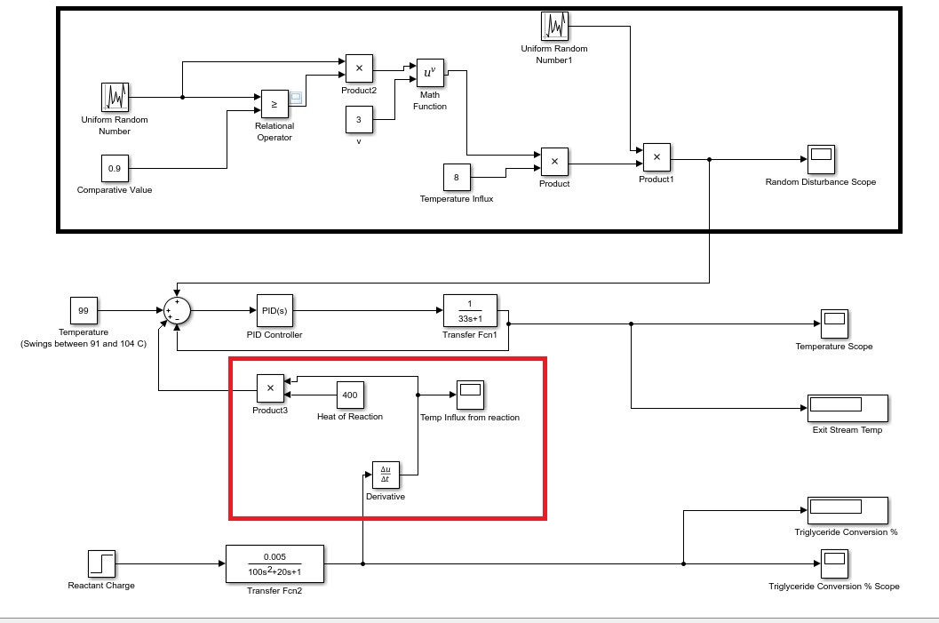
Fig. 1: Simulink Diagram. Section of diagram within the black rectangle was used to generate random temperature disturbances. Section in red calculates an approximate heat of reaction.

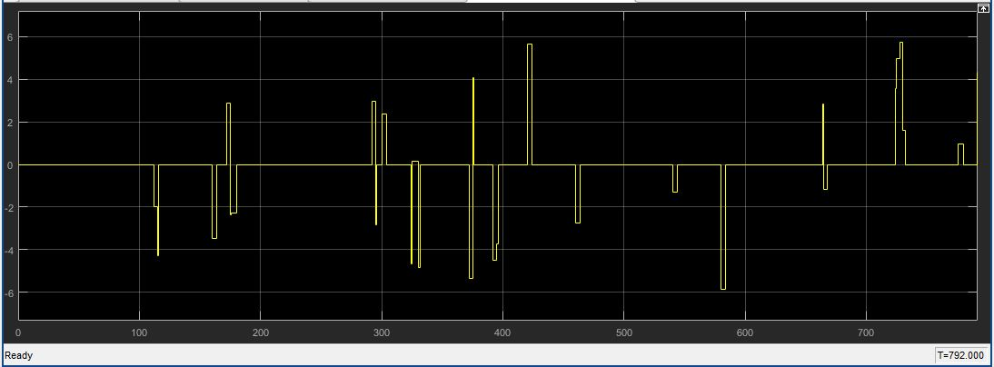
Fig 2: Random Disturbance Scope, represents randomly generated temperature fluctuations. The vertical axis represents change in temperature (degrees Celsius) and the horizontal axis is time in terms of hours (792 hours = 33 days).
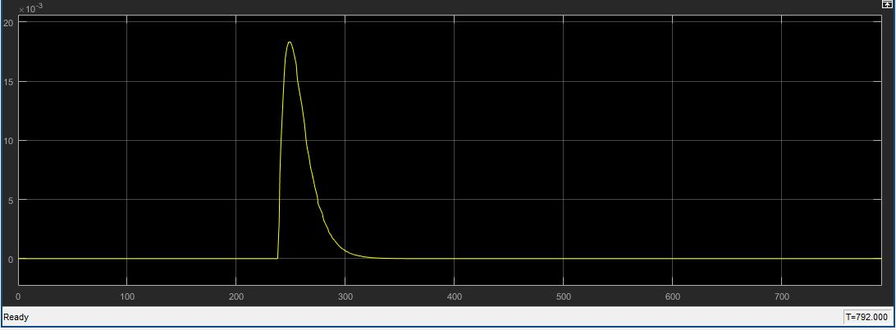
Fig. 3: Temp Influx from reaction, spike indicates a release of heat at the time of reaction. The vertical axis represents change in temperature (degrees Celsius) and the horizontal axis is time in terms of hours (792 hours = 33 days).

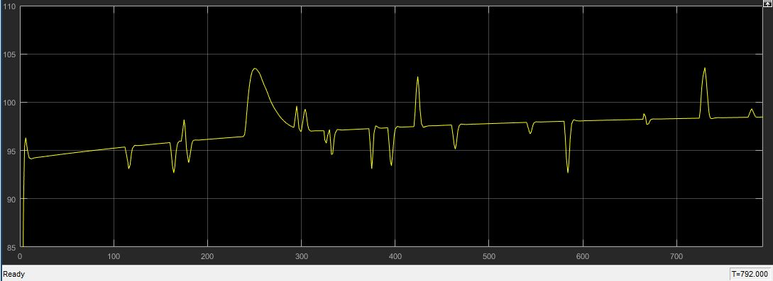
Fig. 4: Temperature scope for the duration of the process, where the vertical axis is temperature in degrees Celsius and the horizontal axis is time in terms of hours (792 hours = 33 days).

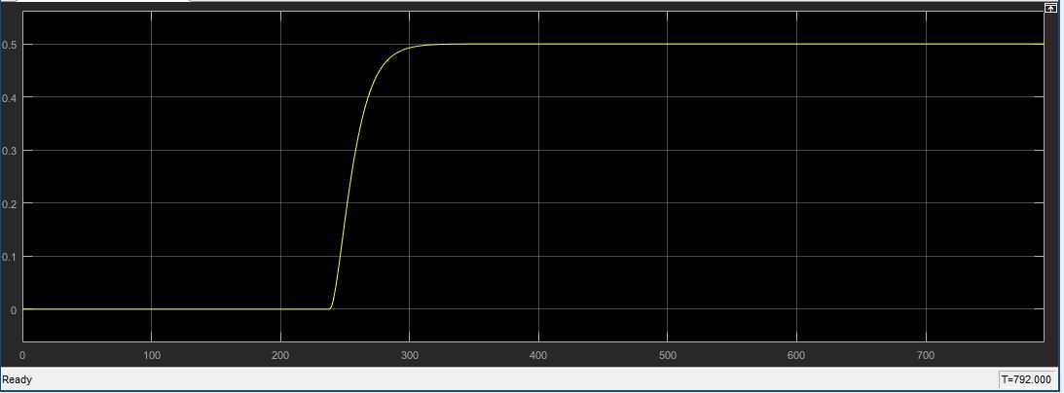
Fig. 5: Triglyceride conversion percentage scope, where the vertical axis is conversion of triglyceride into products by percent weight, and the horizontal axis is time in terms of hours
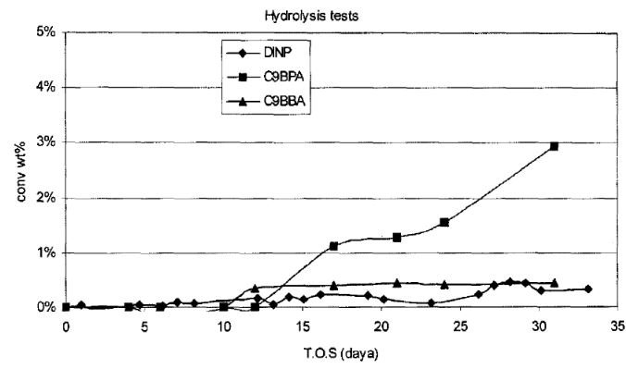
Fig. 6: Figure from the patent.

Works Cited:

- Dakka, Jihad Mohammed, Edmund John Mozeleski, Lisa Saunders Baugh, Colle Karla Schall, Allen David Godwin, Diana S. Smirnova, Jorg Friedrich, Wilhelm Weber, and Stephen Zushma. “Aromatic Acylation with Cyclic Anhydride for Plasticizer Production.” ExxonMobil Research and Engineering Company, assignee. Patent US 9,580,571. 28 Feb. 2017.
- Štampar, Simon, Saša Sokolič, and Gorazd Karer. "Nonlinear Control of a Hybrid Batch Reactor." Journal of Mechanical Engineering. University of Ljubljana, Faculty of Electrical Engineering, Slovenia, 2013. Web.

