Patent Background and Overview
The patent being considered was submitted by PepsiCo as a new way of creating diet carbonated soft drinks, or CSD’s. Traditionally, diet soda is sweetened by derivatives of the Stevia rebaudiana, Rebaudiosides A-E, that are approximately 200x more potent that sugar. Rebaudioside A is the most used in the diet CSD industry; however, it can have an off taste and ruin the desired flavor of the diet CSD. Rebaudioside D,or Reb. D, has a much more desirable flavor profile but, its solubility is not high enough to be used presently in industry. This calls for a new process to be developed and a patent filed.

This patent details two different processes of achieving the same thing: a diet CSD sweetened with Reb. D. Two images are provided to detail these processes.
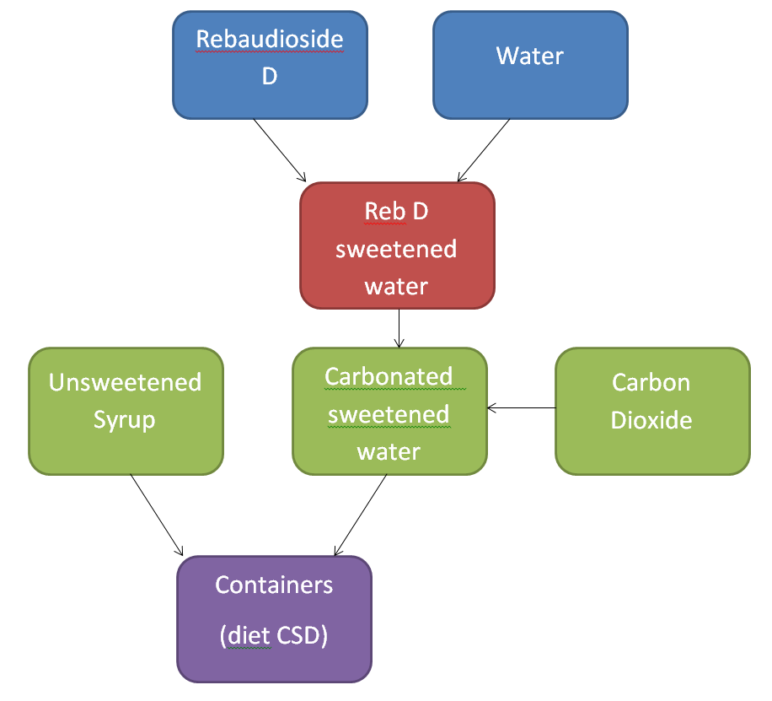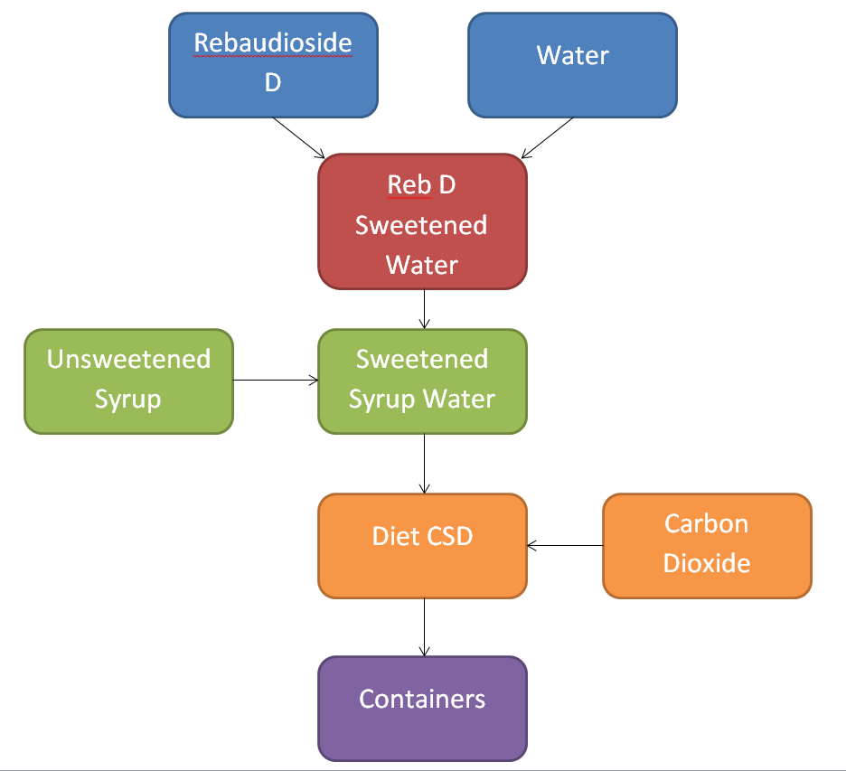
Our group decided to model the second procedure, where carbonation is done in the last step, because it was observed that the mixing of the unsweetened syrup and Reb. D sweetened water, a continuous process as detailed by the patent, would be good for process control, modeling and simulation.

Our Process vs. Regular Soft Drink Processes:

We compared our process to that of a regular soft drink and noted the major differences. In a regular soft drink unsweetened syrup is mixed with sugar, either glucose or fructose, and then added to water in a CSTR to form a concentrated syrup water. The concentrated solution is then mixed with water to create the ideal mixture, which is then carbonated and bottled. In PEPSICO’s method of producing diet soft drinks using Rebaudioside D, the sweetener (Reb. D) is mixed with water, which is then mixed with the unsweetened syrup and carbonated. This ideal mixture that was created is sent out for bottling. The major differences between making regular vs. diet soda lie in the type of sweetener used and at what point in the process the sweetener is added. In the diet soda making process the syrup is sweetened rather than the water being sweetened before mixing and carbonation take place. This small variation in when the sweetener is added marks the biggest difference in this new process as compared to other processing methods.

LabView & Regression

After defining our process of making diet Pepsi, we utilized LabView to model the system. Basing the mixing off of Example 2.1, a mixing CSTR, our output data showed a step input as well as a first order response (Shown below).
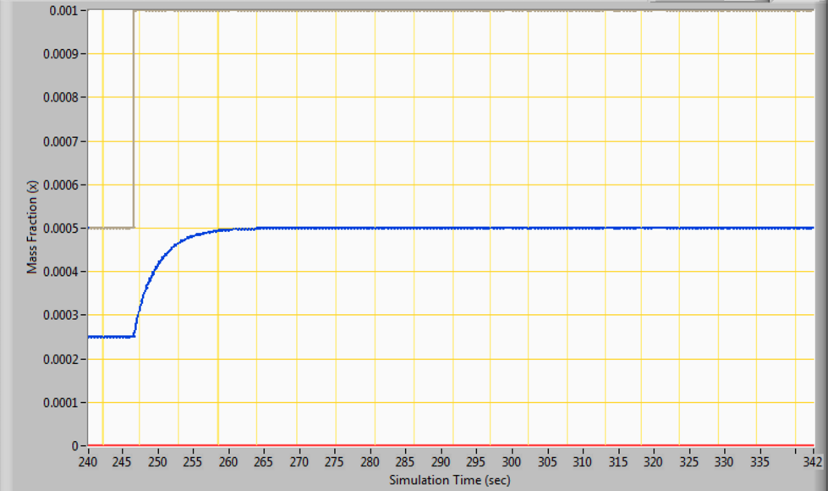
LabView Output
In order to solve for the constants associated with this first order function, we imported the results data into Excel to perform nonlinear regression. The plot, below, shows the accuracy of the experimental model.
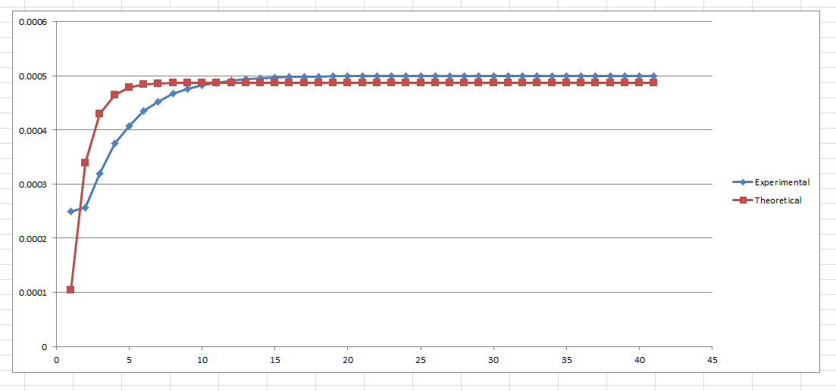
Excel Regression
The constants came out to be K=1.9741, M=0.0005, and 𝜏=1.0548. This experimental model had a sum of squared errors (SSE) of 6.127e-08, meaning it is a very good approximation of the theoretical model. Upon finishing this nonlinear regression, we noticed that even though the SSE value was very low, the steady-state value was not reached for a while. This is a problem we will address later, as the function is still a good model for the system.

Simulink Model and Results

Once the values of 𝜏 and K had been determined, we used those to build our transfer function and process model in Simulink, which is pictured below.
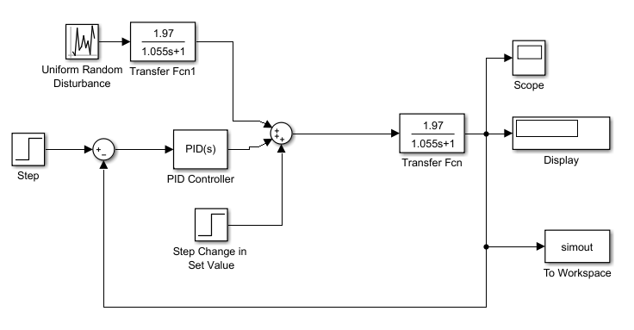

Simulink Model

The final value of the ‘Set Value’ block was equal to 0.0005, or 500ppm, and this block was used to show our initial concentration of RebD. The best PID controller values were found to be P=1.5, I=0.5, and D=2.5, these values were found to be effective in controlling the system both after a step change, or after a sinusoidal change to our input value, showing that the model can be applicable to many situations. In the final model, however as step change was used as this is the most likely way the patent will be implemented in industry. We also added a Uniform Random Number Generator, set to output random numbers between -0.0001 and +0.0001 at 0.1 second intervals, this allows our model to account for some of the random disturbances that may occur in real life and cannot always be determined before constructing the actual system. After running our simulation for a time of 100 seconds, the following plot of Mass Fraction vs Time was generated.
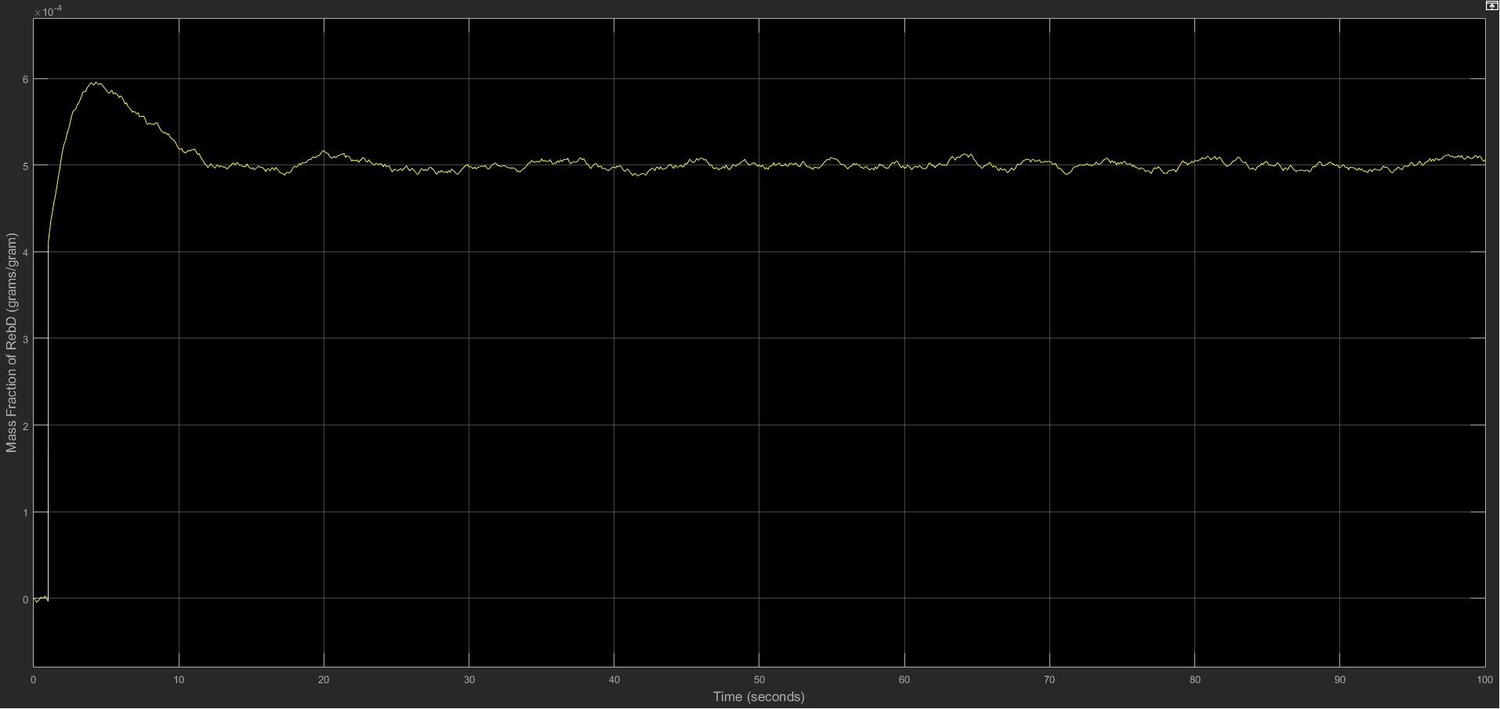
Simulink Graph

The maximum value reached by our system was just below 600ppm, however that overshoot was quickly corrected by the PID controller. The data on this plot was also exported to the Matlab workspace using the simout block and subsequently copied to Microsoft Excel. This allowed for an analysis of the data which showed that once the system reached its steady state value of 500ppm (or 5*10^-4 grams/gram) the maximum percent deviation from that set point was about 3.45%, which we considered to be sufficiently accurate.

Potential Improvements:
There are many potential improvements that we would have made given more time. Some include finding the transfer functions of the valve and transmitter in order to make our model as accurate as possible. Since our patent specified two different models, if we had time we would have made the second model and compared it to ours to identify which one is more accurate and has less variability. If given more time our group would have also found the sensitivity limits in order to understand the ranges in which the model can function properly and installed certain safety measures if those limits were reached. We would have set up critical alarms first for if a specified measurement went out of its range, these would be operator controlled as well. The next layer of safety would be a SIS, so if the emergency cannot be controlled by the first level of safety then the process will begin shutting down. Anything coming into or out of the CSTR would have a fail close valve, so if an emergency occurs nothing would enter into the CSTR and nothing would start pouring out that could potentially contaminate other batches. The last thing our group would do if given more time would be alter our original transfer function in order to reach steady state under five tao, in order to make our model more efficient.

Conclusions

It can be concluded that our model works with less than 5% deviation from the desired mass fraction once steady state is achieved. This is ideal for our process because Pepsi will desire consistency throughout all of their drinks and will need a constant mass fraction of Rebaudioside D to ensure that their product is of the highest quality. There are several improvements however that would be desired before implementing our model into Pepsico’s manufacturing line. A few of these improvements include adding alarm systems and reducing the time required to reach equilibrium. Alarms and fail-safes are a necessary part of any model and are designed to save Pepsico from losing money, product or even lives. The model in its current state takes about 15 tau to reach steady state, ideally we would want to develop a model to reach steady state at about 5 tau. Also a sensitivity analysis to determine the range of control settings for which the model is stable would be necessary before delivering our product to Pepsico. Overall our patent model would be a very attractive product for Pepsico because it maps an important part of their process and will provide the ideal startup times to reach steady state.

