May 1st, 2017

I pledge my honor that I have abided by the Stevens Honor System.
RLB PF ES TC AR MR

US Patent for Azeotrope-like Composition of Cis-1,1,4,4,4,-Hexafluoro-2-Butene

This patent, produced by Honeywell International Inc., describes the discovery of azeotrope-like compositions of the compound of Cis-1,1,4,4,4,-Hexafluoro-2-Butene. The structure of the compound can be seen below (Figure 1):
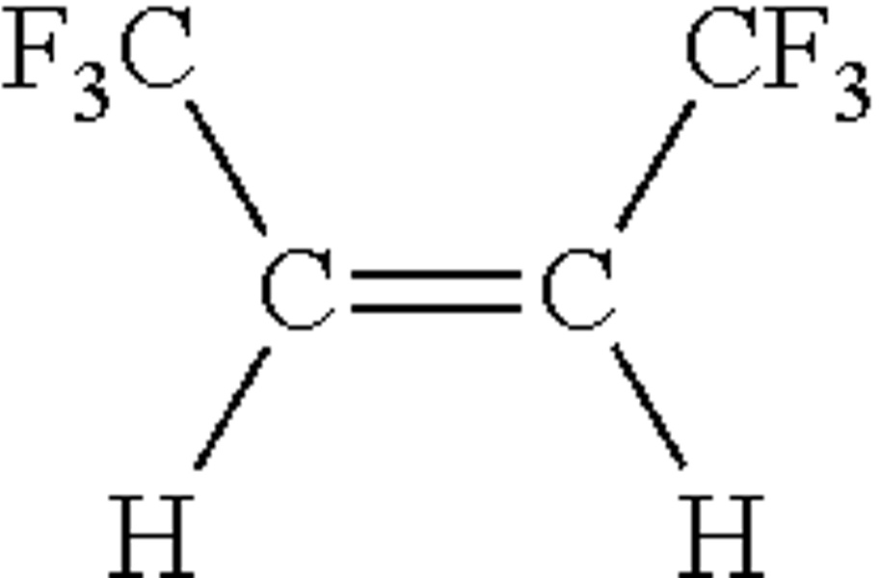
Figure 1: Cis-1,1,4,4,4,-Hexafluoro-2-Butene
This compound produced by Honeywell is specifically chosen due to its limited impact on the environment and its multiple applications, including: refrigerants, heating agents, cleaning agents, lubricants, and blowing agents. Our team decided to focus on the refrigerant application of the product described using the process in the patent. Refrigerant mixtures are a combination of two or more pure fluids; these mixtures tend to have azeotropic or near azeotropic properties. These chemicals are used because they act like a pure fluid. In a typical azeotrope, at constant temperature and pressure, the composition will remain the same. For this patent, the team has discovered that the compound, when combined with a number of other species (such as methanol, ethanol, trans 1,1,1 trifluoro-3 chloropropane, dodecafluoro-2-methylpentan-3-one, and water), forms an azeotrope-like mixture. When mixed, the products will act as an azeotrope-like mixture over a large composition range, rather than a typical azeotrope which occurs at a single composition point. Because of this aspect of the azeotrope-like mixture, multiple compositions can be tailored to specific applications. These products can be potentially used to replace hydrochlorofluorocarbons (HCFCs) and chlorofluorocarbons (CFCs), which are commonly used in refrigerant materials, but have shown to have a large impact on the ozone layer and are banned in several countries.
The patent itself does not include a specific process; rather, it outlines the purpose of the invention and provides data related to the azeotropic mixtures with different compositions. It also gives information about possible applications of this azeotrope-like. One application was a refrigerant, so the team decided to model a heat exchanger that can be found in a refrigerator. When the temperature inside the refrigerator is changed (due to a disturbance such as opening the door), the process has to control the flowrate of refrigerant entering the system in order to keep the temperature inside the fridge below that which would cause food inside to spoil. For our project, it is important to keep low oscillations and minimal overshoots because a hike in temperature can be potentially dangerous to the food inside.
We modeled the heat exchanger portion of a refrigerator system. To do so, a refrigerant is used to cool down the air inside a refrigerator through heat transfer. The flow rate of the refrigerant is controlled through a series of transfer functions and a PID controller which will ultimately control the temperature of the refrigerator. The control variable for our system is the temperature inside the fridge. This system can be disturbed by an act that would change the internal temperature such as a door opening/closing or left open. For our system, the temperature is being converted to a voltage. This voltage is controlled and converted to a pressure change. The pressure change is then transferred to a flow rate of the refrigerant, which acts as the manipulated variable that can help control the temperature changes. Our refrigerant, in this case, is the compound of Cis-1,1,4,4,4,-Hexafluoro-2-Butene, and the change in flow rate can cause more or less refrigerant to be used to cool down the fridge.This control will hopefully keep the fridge internal temperature at a reasonable temperature without any major spikes that cause the food to spoil.
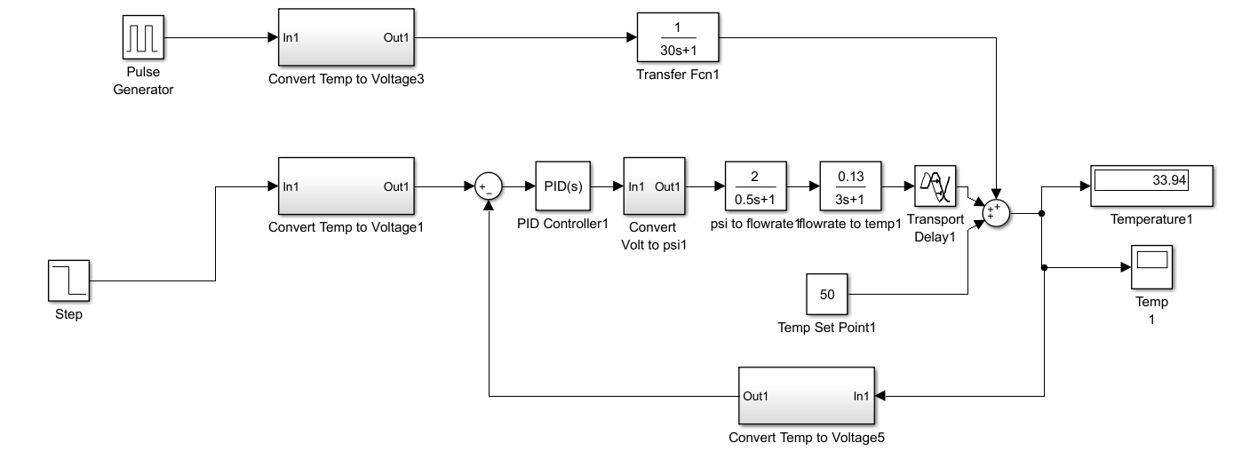
Figure 2: Simulink Model
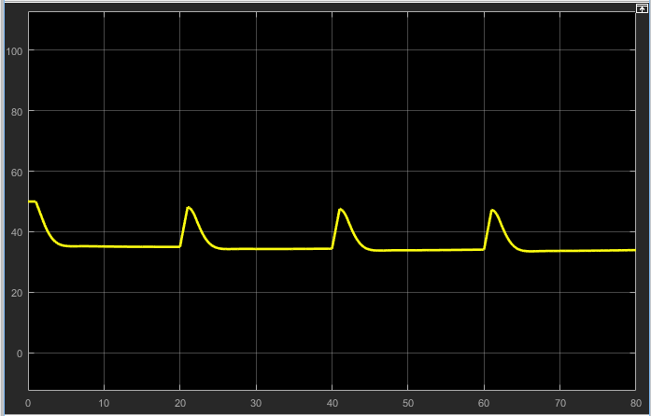
Figure 3: Temperature vs Time
The model (Figure 2) begins with a step input into the system. Afterwards, the temperature is converted into a voltage using a linear relationship and fed into a PID controller. The values of the PID controller were tuned in accordance with our system to reach steady-state quickly and without overshoot. PID was used over other controllers such as PI or P because it offers the best feedback control (Figure 3) by taking into account errors caused by present values, past values, and future values with the respective Proportional, Integral, and Derivative blocks. Other controllers are not as constant or stable; in Figure 4, you can see the P controller drifting away from the desired controlled temperature.
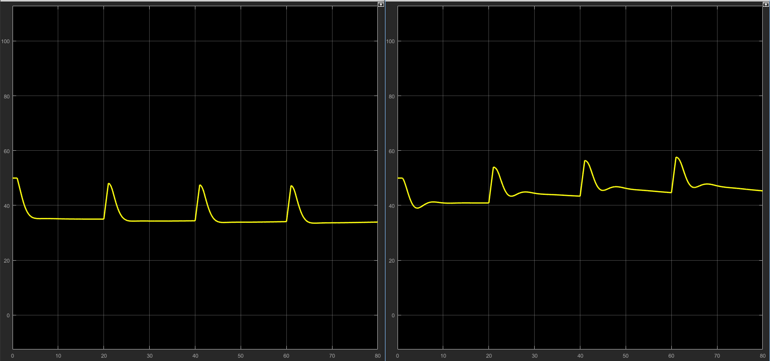Figure 4: PID vs P Controller

Next, is a series of constants and transfer functions that represent the temperature change being adjusted by the system; in this scenario a pressure change turns the tank valve thus adjusting the refrigerant flow rate. A transport delay is added to the system so that the disturbance will be taken into account before the controller modifies the refrigerant flow rate. Without this delay in time, the system may change the flow rate before the disturbance is added in. When hot air enters the system due to a disturbance such as a pulse, or a hungry person opening the refrigerator, flow rate will increase and effectively lower the temperature back to the steady-state value required to keep food preserved. In Figure 3, the results of the temperature change is visible; the temp peaks when there is a temperature changes and is then adjusted back to the original temperature of 35 F. Transfer functions were first based off of online literature (Padhee), but afterwards, they were adjusted to fit the process of a refrigerator, resulting in the following transfer functions.
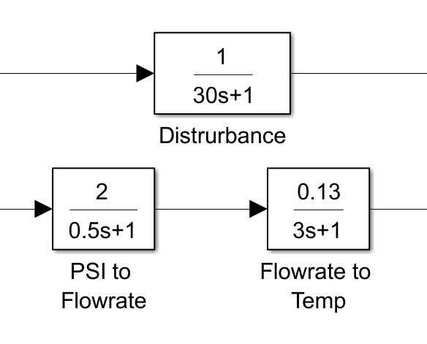
Figure 5: Transfer Functions
It is dangerous to keep food above 42F because it may spoil but it is also harmful to keep food below 32F because water found inside the food will freeze. For these reasons we tuned the system’s PID controller and transfer function to be consistent with minimal overshoot.
In conclusion, the model created by our group appears to successfully model a refrigerator’s heat exchanger. Utilizing the information from the Honeywell patent, the compound Cis-1,1,4,4,4,-Hexafluoro-2-Butene together with our simulink model is able to accurately keep the temperature inside a refrigerator between 32F and 42F. Through a PID controller, multiple transfer functions and a delay, the model is able to accurately respond to different human actions such as the refrigerator’s door opening and closing. Patents such as this one are very important in moving to more environmentally friendly refrigerants and allowing us to live in a safer world.

Works Cited
Padhee, Subhransu. "Controller Design for Temperature Control of Heat Exchanger System: Simulation Studies." (n.d.): n. pag. Http://www.wseas.org. Web. 23 Apr. 2017. <http://www.wseas.org/multimedia/journals/control/2014/a125703-288.pdf>.

