Bristol-Myers Squibb: Compound for the Treatment of Hepatitis C
Patent US9556162B2

Team Five:

Danielle Adams
Paige Brown
Andreas Buehlmann
Cristina Chiacchiero
Brittany Jewett
Jovanna Manzari
Lauren McTigue

Due May 1, 2017

“I pledge my honor that I have abided by the Stevens Honor System”

Danielle Adams Andreas Buehlmann Cristina Chiacchiero Paige Brown Brittany Jewett Jovanna Manzari Lauren McTigue

Project Introduction
Bristol-Myers Squibb Company’s patent issued for the Process of Making a compound for the treatment of the hepatitis C virus (HCV). HCV affects 170 million people throughout the world. A substantial portion of those affected by this virus develop a serious liver disease which includes cirrhosis and hepatocellular carcinoma. HCV is a positive stranded RNA virus. There has been found to be considerable heterogeneity within the nucleotide and amino acids sequence of the HCV genome. Six genomes as well as 50 subtypes have been characterized. It is still unknown if these variances are clinically significant. One strand of HCV RNA genome consists of 9500 nucleotides and encodes one polyprotein consisting of 3000 amino acids. In cells affected by HCV this polyprotein is cleaved at multiple sites to produce structural and non-structural (NS) proteins.
The most effective treatment for HCV utilizes a combination of alpha-interferon and ribavarin. Interferons are similar to the proteins the human body produces to fight off infection. Ribavarin increases the chances of expelling the virus from the body. This treatment leads to a sustained efficacy in 40% of patients. Even with this treatment, a large number of patients don’t see a decrease in viral load. There is still a large number of patients that can benefit from alternative therapies.
One alternative therapy that was tested included an HCV-796 and HCV NS5B which has shown the ability to decrease HCV RNA levels. With this treatment as a singular agent, levels quickly rebounded. However, when combined with the previously stated treatment of interferon and ribavarin, levels dropped more dramatically. This treatment was suspended due to toxicity observed over long periods of use.
This invention provides technical advantages as well as pharmaceutical advantages with regard to mechanisms of action, binding, inhibition efficiency, target selectivity, solubility, safety profiles, or bio-availability. There are many aspects of the invention which make it a good alternative to the common forms of therapy, which can all be found in Patent No. US 9,556,162 B2.

Control Objectives
To ensure that the necessary compounds are created it is important to control the temperatures at which the reaction takes place. For this reason our control objectives are to first, heat the mixture of sodium hydroxide, ethyl 6-bromo-2-(4-fluorophenyl)-5-isopropoxybenzofuran-3-carboxylate, MeOH and THF to 40 degrees Celsius and have it remain at this temperature for 12 hours, and second, to cool the mixture to 0 degrees Celsius with the addition of HCl.
With these objectives in mind, the control variables for this reaction can be set. Control variables are variables that are set to a specific value for the duration of the reaction. For this reaction the control variables are the temperature of the mixture of sodium hydroxide, ethyl 6-bromo-2-(4-fluorophenyl)-5-isopropoxybenzofuran-3-carboxylate, MeOH and THF which will be set to 40 degrees Celsius, and the temperature of the mixture after HCl is added which will be 0 degrees Celsius.
Manipulated variables are the variables that are adjusted in order to allow the control variable to remain at a set point. For the heating of the initial mixture the manipulated variable is the flow of the steam that is heating the mixture. An increase in steam will continue or speed up the heating while a decrease in steam will slow down the heating or stop it completely. For the cooling of the mixture with the addition of HCl, the manipulated variable will be the flow of the water the cools the mixture. Similar to the first manipulated variable, a increase in water flow will speed up the cooling process while a decrease in water flow will slow the cooling process.
Finally, disturbance variables are variables that have an effect on the control variables in the process but are not able to be manipulated. A disturbance variable could be anything that disrupts the process and can range from operator errors to dramatic weather changes. In this model the disturbance variable would be changes in the temperature of the surrounding air due to human error. For example, a door could be left open when an operator leaves for lunch. This would allow the air temperature in the room to cool which would then cool the reactor. If the reactor is not checked until the operator returns, the temperature could change significantly before it is corrected.

Process Control

When creating a model, there are two control options to consider: the first is a feedforward loop and the second a feedback loop. As with any type of control they each have advantages and disadvantages. In a feedforward control loop an input, usually a disturbance variable, is measured and the controlled variable is adjusted accordingly. The main advantage of this method is that the controlled variable is adjusted as soon as the disturbance is detected. Therefore, the error of the disturbance is canceled out before it can affect the outcome of the system. If the disturbance variable is not correctly estimated or if there are more than one disturbance variables, adjusting the control variable may not be enough to correct the system’s errors. This is one of the disadvantages of this type of control loop.
In a feedback control loop, the controlled variable is measured and the manipulated variable associated with the control variable is adjusted accordingly. The disturbance variable is corrected for after the fact, once the system output has registered it. Unlike in a feedforward control loop, the disturbance does not matter. The model can adjust to account for many different types of disturbances and that is the main advantage of a feedback control loop. The main disadvantage of this model is that unlike a feedforward, the correction to the disturbance is not instantaneous. The disturbance has to first occur for the system to measure the error before it adjusts, at times allowing the system to be out of ideal conditions. The disturbances determined for the process modeled included: temperature differences in the surrounding area, temperature ranges of the component streams coming into the reactor, and many different forms of human error. It was decided that a feedback control loop would work the best due to the variety of disturbances that could occur.
In this model, many different process control elements were used. Initially the temperature is taken with a thermocouple. The heating begins with a transducer that converts the temperature to a current. This is necessary so that the current can be a universal signal for the PID controller to interpret. Next is a PID controller. The PID controller is a very robust and high performance element of control that can respond smoothly. A tradeoff with PID is that it tends to have overshoots in its ideal case. In this model, the ideal case was not used to avoid the oscillatory overshoot. The heating is “gentle” so the team prioritized a slower heating over a quick, oscillatory response. Next, another transducer to convert the current to a pressure. Then, there is a valve that controls a linear flow rate. The heating value is a fail close valve because if the system gets to a temperature that is too hot, the system should stop heating. The cooling system works very similarly except that the valve is fail open. If the system is working incorrectly, the water released would reduce the temperature and prevent a major issue.

Safety
Safety in the workplace is an standard that stretches across virtually every industry. From having a lid on hot beverages to prevent burns from spills to wearing proper PPE in a refinery many companies enforce strict guidelines to ensure not only are their employees staying safe but the communities that they operate in are. As presented in Patent US9556162B2 synthesis of the compound for the Treatment of Hepatitis C occurs in a small scale lab setting. For a lab scale synthesis the associated safety risks are much less severe than in a full scale pharmaceutical manufacturing plant. To mitigate risks of personal injury, lab personnel would be required to wear closed toed safety shoes, long sleeve lab coat, safety glasses, gloves, and other chemical specific clothing when required by MSDS instructions.
As the process is scaled up for high yield of the final product not only do the amount of safety risks grow the magnitude of the risks. Instead of a hot plate, beaker, and stir bar for heating and mixing the components a reactor chamber ranging anywhere from 100-1000+ liters with a internal heating and cooling system and mixer would be used. Unlike in the lab you are not able to measure and add each component into the industrial reactor as it is closed system controlled through programming. One way to identify potential hazards is to conduct a hazard and operability study (HAZOP), in which the plant and process is systematically examined to identify and evaluate problems that may represent risks to personnel or equipment.
For the industrial scale up of the process presented in Patent US9556162B2, there is a chance for the reactor to overheat, this could cause the product to become unstable and could lead to an explosion, one way to mitigate this is by implementing a feedback loop to monitor the temperature and make adjustments to the heating/cooling loop. In addition to a feedback loop it would be important to install alarms to notify the unit operators of rising temperatures if the feedback loop were to fail and if necessary implementing an automatic shutdown of the process if the associated risks are grave enough. In addition to ensuring that the temperature does not rise beyond set temperatures, it is imperative to make sure that the reactor does not get filled beyond its holding limits, there are many different strategies to ensure overfill doesn’t happening including but not limited to, having operator input restrictions, and liquid level measurement alarms.

Process Simulation Model
The model shown in Figure (1) is an accurate representation of the process of heating and cooling the mixture. The mixture is heated and cooled in a batch reactor. The step inputs set the desired temperatures of the reactor (40°C for heating and 0°C for cooling). The cooling is delayed using a step time of 12+ 3tau2 to model the overnight heating before the mixture is cooled. This temperature input is converted to a signal and the measured output is subtracted from the input value. This error goes through the PID controller, which is controlled by the transfer functions that follow it. The integrative and derivative parts of the controller are calculated using the equations from table 12.1 in the text. Using this reference, the integrative formula was 1/(tau1+tau2) and the derivative formula was (tau1*tau2)/(tau1+tau2). The proportional value is a constant that was chosen arbitrarily to best this situation. The first transfer function models a valve and converts the incoming signal into a pressure and that pressure goes through the second transfer function which converts it back to a temperature. The values of the time constants were chosen by first creating the process gain block. Assuming the desired upper value should be reached quickly, the heater was modeled to take about half an hour to reach 40° C. To model this, the time constant for the process block was chosen to be 0.5. Then, the values of tau for the remaining transfer functions were determined respectively taking into account the fact that they must be less than or equal to the time constant for the process block. The room temperature is taken into account as well as a disturbance variable. The room temperature is assumed to be 25°C and it is assumed that this is constant. The disturbance is the result of an operator leaving the door to the plant open during a heavy snowstorm. As you can see in the graph pictured in Figure (3), the temperature dips down below 40°C at hour 5. This step input has to be transferred into a temperature using the same 2 transfer functions that were previously discussed. Lastly, the feedback loop returns the measured output to the beginning of the loop and makes the process continuous. The transfer function in the feedback loop converts the temperature output into a signal which can be subtracted from the input signal. The first part of the model depicts a model with no oscillations. This is the model that to be being used to describe the process in the patent. Typically, a model allows for some oscillations in order to reach the desired setpoint in a shorter amount of time. However, due to the fact our process specifically calls for “gentle heating”, our group decided that oscillations would not be appropriate for this case. The lower half of the model, which was only used for comparison, allows for oscillations to occur. To create these oscillations, the proportional value in the PID controller was changed. The graph that compares the both the model with and without oscillations is seen in Figure (2).

Conclusion
In conclusion, the process used by Bristol-Myers Squibb to manufacture the 6-Bromo-2- (4-flourophenyl)-5-isopropoxybenzofuran-3-carboxylic acid compound in the Hepatitis C treatment can be modeled using a Simulink model. This model demonstrates two parts of the reaction. The first is the process of heating the initial mixture of sodium hydroxide, ethyl 6-bromo-2-(4-fluorophenyl)-5-isopropoxybenzofuran-3- carboxylate, MeOH and THF to 40 degrees Celsius and then maintaining this temperature for 12 hours using a steam system. The second aspect of the reaction shown in Simulink is the cooling of the mixture when HCl is added to 0 degrees Celsius using a cooling water system. The use of PID controllers in a feedback system allows the model to demonstrate the effects that a disturbance variable can have on the system as well as how the reaction can recover from a disturbance.
Through this project the team learned how to use Simulink and fine tune the interactions between different blocks to accurately model the system described in the Bristol-Myers Squibb patent. The team also gained a better understanding of the feedback and feedforward control systems as well as other means of monitoring a reaction to ensure that the desired results are reached. Additionally, the team learned about necessary safety measures that must be used to sustain a reaction and if it is successful, scale the reaction up. Finally, the team was able to learn a lot by working with a group of people with a diverse skill set to create a working a model while drawing from our unique classroom, industry, and laboratory experiences.

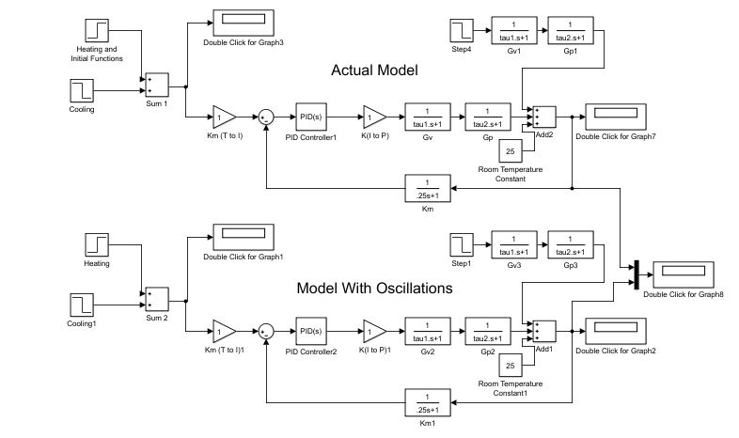
Appendix:
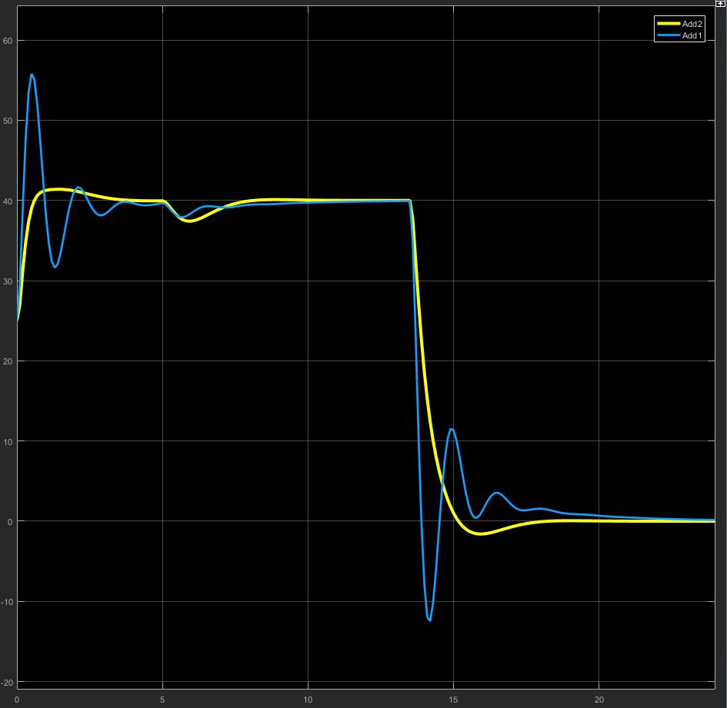
Figure (1): Simulink Model of the Process

Figure (2): Combined Graph of Actual Model and the Model with Oscillations
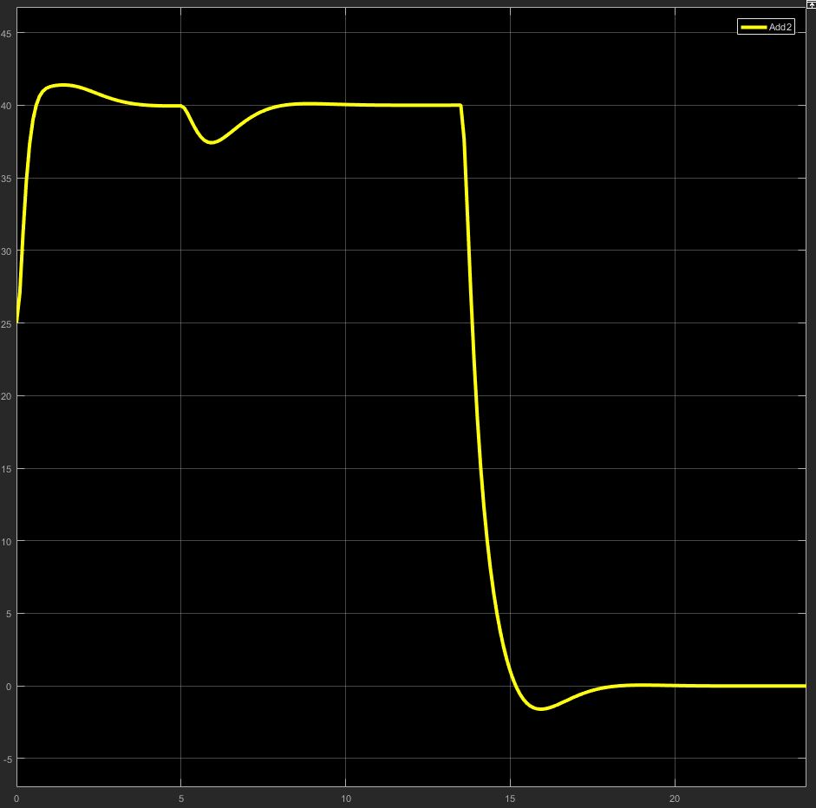
Figure (3): Graph of Actual Model
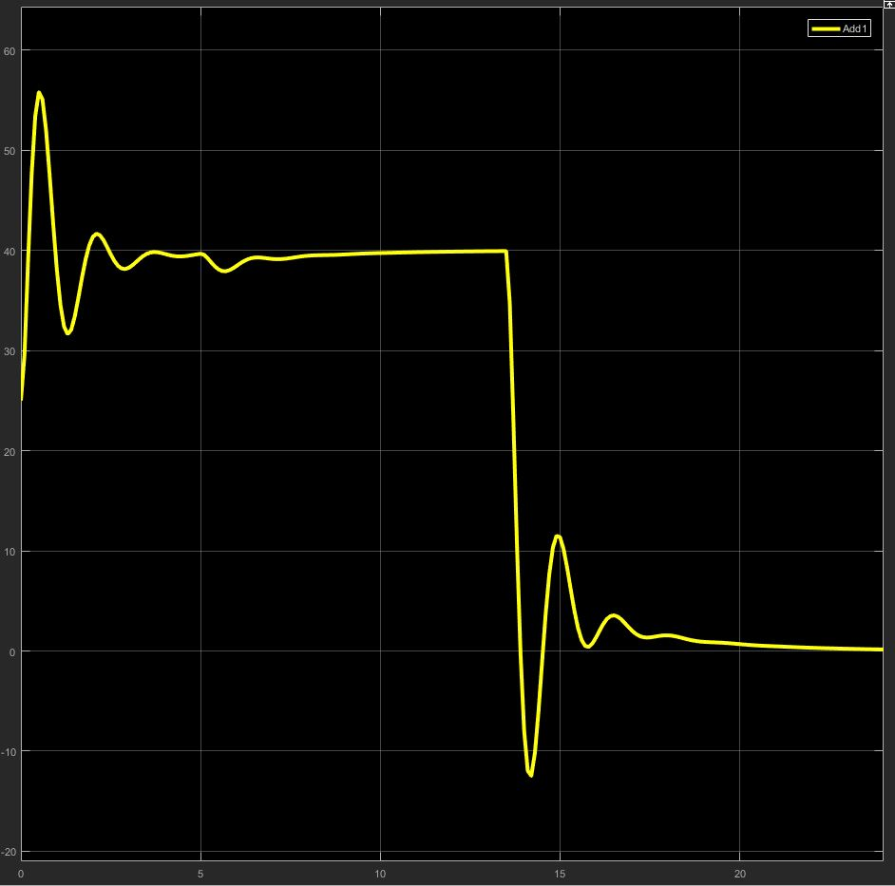

Figure (4): Graph of Model with Oscillations

