ChE 345

Process Control Modeling and Simulation

Group 7
Will Murtishaw
Kaitlyn Molnar
Athina Glindmeyer
Ping Qu
Handun Zhang
Caitlynn Reilly
Muyang Guan

Date: 2017/05/01

“I pledge my honor that I have abided by the Stevens Honor System.”

x____Will Murtishaw___________________________________________
x____Caitlynn Reilly___________________________________________
x____Athina Glindmeyer________________________________________
x____Ping Qu________________________________________________
x____Handun Zhang___________________________________________
x____Kaitlyn Molnar___________________________________________
x____Muyang Guan___________________________________________

The purpose of this report is to explain the Process Control Modeling and Simulation project completed by Group 7. The patent was selected from a set provided by the teaching assistant, Jason Robbins. This will integrate learnings from class, as well as the information provided by the patent. Since this is a long process, the team chose to model a part of the process, using transfer functions. The transfer functions and process will be explained in this report.
The patent being modeled by the group was created by Merck Sharp & Dohme Corp., in Rahway, NJ; it was filed on October 19, 2015 and approved on February 14, 2017. The patent is for triazolopyridyl compounds, with the physical structure shown by Figure 1. These compounds can help treat cardiovascular diseases caused by an excess of aldosterone, an adrenal steroid that retains sodium and water while excreting potassium from the body. Excess of sodium can increase blood pressure and lead to inflammation leading to hypertension and heart failure.
The group modeled the synthesis of 2-heteroaryl triazolopyridines, as depicted by Scheme 2 of the patent. According to scheme 2 in column 22, the reaction is:
$2-amino pyridine (A) +cyanopyridine (B) →N-(2-pyridyl) nicotinamidine(C)$
$N-\left(2-pyridyl\right)nicotinamidine\left(C\right)+Pb\left(OAc\right)\left(D\right)+Toluene \left(E\right)→ 2-heteroaryl triazolopyridine (F)$
Which can be simplified to: $A+B→C$ & $C+D+E→F$.
The main controlled variables are the outlet flow concentrations of 2-heleroaryl triazolopyridines and N-(2-pyridyl)nicotinamidine. The main control objective is to maintain the outlet flow concentrations of 2-heleroaryl triazolopyridines at its setting point. This will be achieved by controlling the manipulated variables – the mass flow rates of the feed streams of 2-amino pyridine, cyanopyridine, N-(2-pyridyl)nicotinamidine, and lead tetraacetate. The disturbance variables will be changes in the concentrations of either of these components.
The control strategy will be feedback control with the use of a PID controller. The advantages are that the corrective action will be taken regardless of the disturbance, and reducing the sensitivity of the controlled variable to disturbances in the process. The disadvantages are that the response could be very oscillatory, and the corrective action would only be taken after the disturbance has upset the process. Sensors would be used to measure the concentration values of each stream. Valves would be used to control the mass flow rates of the streams and were simulated by a transfer function after the PID controller. And transmitters would be used to control the valves of the process streams.
The group assumed those reactions happened in 2 tank reactors in series; all the reactions were assumed to be first order:
$$r_{C}=k_{1}*C_{A}+k_{2}*C_{B}$$

$$r_{F}=k_{3}*C_{C}+k_{4}*C_{D}+k_{5}*C_{E}$$

In addition, the group made assumptions about variables: $V_{1}$, $V_{2}$, $v$, $v$’, $C_{i}$, and $k_{i}$, as referred to the volumes of Tank 1 and 2, volumetric flow rates of components C and F, concentration values and kinetics parameters of all components. Molecular weights $W_{i}$, and time constants $τ=\frac{V_{1}}{v},τ'=\frac{V_{2}}{v'}$ were also used. Mass balances were then established in order to model the described process.
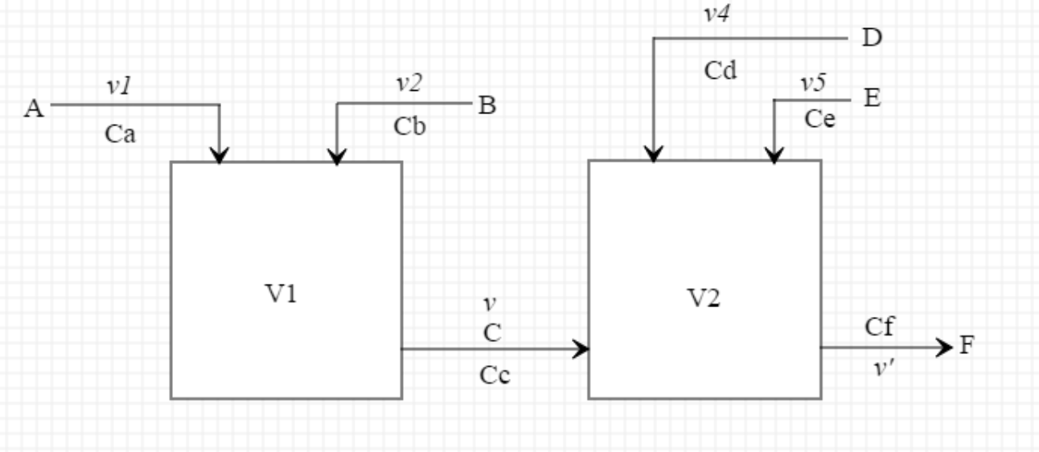
Reaction Process
Mass balance in tank 1:
$$\frac{d(C_{C} V_{1}W_{C})}{dt }=-C_{C}*v*W_{C}+(k_{1}*C_{A}+k_{2}*C_{B})*V_{1}*W_{C}$$
$$V_{1}*W_{C}*d\frac{Cc}{dt}=V_{1}*W_{C}*(k_{1}*C_{A}+k_{2}*C_{B})-v*W_{C}*C_{C}$$

$$τ\frac{dCc}{dt}=τ*k_{1}*C_{A}+τ*k_{2}*C_{B}-C_{C}$$

$$τ\frac{dCc'}{dt}=τ*k_{1}*C_{A}'+τ*k_{2}*C_{B}'-C_{C}'$$

$$(τs+1)*C_{C}'(s)=τ*k_{1}*C_{A}'(s)+τ*k_{2}*C_{B}'(s)$$

$$⇒C_{C}'(s)=\frac{τk_{1}}{τs+1}*C_{A}'(s)+\frac{τk_{2}}{τs+1}*C_{B}'(s)=G_{1}(s)*C_{A}'(s)+G_{2}(s)*C_{B}'(s)$$

Mass balance in tank 2:

$$\frac{d(C_{F} V_{2}W_{F})}{dt }=-C_{F}*v'*W_{F}+(k_{3}*C_{C}+k_{4}*C_{D}+k_{5}*C_{E})*V_{2}*W_{F}$$
$$τ'\frac{dC_{F}}{dt}=τ'*k_{3}*C_{C}+τ'*k_{4}*C_{D}+τ'*k_{5}*C_{E}-C_{F}$$

$$τ'\frac{dC_{F}'}{dt}=τ'*k_{3}*C_{C}'+τ'*k_{4}*C_{D}'+τ'*k_{5}*C_{E}'-C_{F}'$$

$$(τ's+1)*C_{F}'(s)=τ'*k_{3}*C_{C}'(s)+τ'*k_{4}*C_{D}'(s)+τ'*k_{5}*C_{E}'(s)$$

$$⇒C_{F}'(s)=\frac{τ'k_{3}}{τ's+1}*C_{C}'(s)+\frac{τ'k_{4}}{τ's+1}*C_{D}'(s)+\frac{τ'k_{5}}{τ's+1}*C_{E}'(s)=G_{3}(s)*C_{C}'(s)+G_{4}(s)*C_{D}'(s)+G_{5}(s)*C_{E}'(s)$$

$$C_{C}'(s)=G_{1}(s)*C_{A}'(s)+G_{2}(s)*C_{B}'(s)$$

$$⇒C_{F}'(s)=G_{3}(s)*G_{1}(s)*C_{A}'(s)+G_{3}(s)*G_{2}(s)*C_{B}'(s)+G_{4}(s)*C_{D}'(s)+G_{5}(s)*C_{E}'(s)$$

The first step in order to make the model was to derive the mass balances. After the mass balances were derived, the group could make the Simulink model based on the mass balances equations. The model was based on the following assumed parameters:
$V_{1}=V_{2}=1L$, $τ=\frac{V_{1}}{v}=2 min$, $v=0.5 L/min$, $τ'=\frac{V_{2}}{v'}=4 min$, $v'=0.25 L/min$

$$k_{1}=0.15\frac{1}{min}, k_{2}=0.35\frac{1}{min}, k_{3}= 0.15\frac{1}{min},{ k}_{4}=0.2\frac{1}{min}, k_{5}=0.3\frac{1}{min}$$

The model's purpose is to achieve a new steady state of the output concentration when the set point of the output concentration or either one of the feed concentrations is changed. Meanwhile the model should have the ability to eliminate the effects caused by disturbances (concentration related).
In the Simulink model, 4 step changes can represent both controlled variables and disturbances. In this scenario, the team set step changes of concentration of reactant A, B and F as the controlled variables. We changed the set points of the concentrations of component A by 0.25 mol/L and component B by 0.35 mol/L; the set point of concentration of F was changed from 1 to 3 mol/L (the initial value of concentration F was at 1 mol/L). And the disturbances were simulated by changing the inputs of both D and E by 0.25 mol/L.
A PID controller was added in order to control the error in the reading. This provides an important safety feature to the overall system, by preventing too much variation in the concentrations. Controlling the concentration is key to ensuring the safety of the plant as extremely high concentrations can be harmful. Additionally, this ensures that the recipient of the drug is not harmed by an overdose or under dose. In addition to a PID controller for safety, the plant will contain an alarm such that when the concentration of one of the explosive components is too high the alarm will sound. And the group will ensure that chemicals do not leak during the operation, and wear PPE when around the equipment.
The result was obtained after running the Simulink model. A concentration profile was created with respect to time in the scope block. There was an overshoot in the output with slight oscillation, which was preferred.

