Improvement of the Superabsorbent Polymer Stability

Team Eight
Dakota Baumann
Ian DiGuilio
Geoffrey Lim
Ravi Patel
Inna Petrusenko
Trent Reichert
David Schulz

May 1st, 2017
ChE 345 - Process Control, Modeling & Simulation

“I pledge my honor that I have abided by the Stevens Honor System”
Dakota Baumann, Ian DiGuilio, Geoffrey Lim, Ravi Patel, Inna Petrusenko, Trent Reichert, and David Schulz

Introduction:

The patent assigned to the group was not a new invention, but rather an improvement of an existing patent. In essence, the patent describes the procedure of enhancing the superabsorbent polymer (SAP) by improving stability and reducing functional loss. The superabsorbent polymer is highly valued in industry because it can absorb up to 400 times its own weight. The increase of stability makes the polymer far more resistant to processing and hence reduces the functional loss compared to current commercially available polymer compositions.

The functionality of superabsorbent polymers are assessed with two tests: Centrifuge Retention Capacity (CRC) and Absorbency Under Load (AUL). In order to test the capacity of the SAP, the Centrifuge Retention Capacity test is usually implemented. A solution of SAP and 0.9% saline is made up and then placed into a tea bag like contraption which is then centrifuged to remove particles. To assess the strength of the superabsorbent polymer, the AUL procedure is used which simply uses a small amount of the SAP under various amounts of loads measuring retention. The effect on the permeability by the two tests, CRC and AUL, can be seen in Appendix I.

The modified polymer composition has an increase of base monomers from 0.01 wt% to about 5 wt% and an addition of 0.9 wt% of sodium chloride aqueous per gram of particulate superabsorbent polymer composition. These improvements to the polymer better the centrifuge retention capacity from 25 to 40 grams. The addition of sodium chloride to the particulate superabsorbent polymer compositions enables it to uptake bodily fluids much quicker than in the past. This is possible because as salt concentration increases, the ability to swell to decreases via reduced osmotic pressure. With the enhancements listed above the new superabsorbent polymer composition gained a permeability stability index from around 0.60 to about 0.99.

Commercial particulate superabsorbent polymer compositions are widely used in a variety of personal care products, such as infant diapers, child training pants, adult incontinence products, feminine products and the like. Due to how the SAP is predominantly used, total capacity and retention are very important because they relate to skin dryness (retention), risk of leakage after extended use (absorption), and SAP capacity and concentration (absorption and retention).

Selection of Relevant Variables:

The different variables within the model were defined: (1) controlled variables, (2) manipulated variables, and (3) disturbance variables. Controlled variables are the variables that are manipulated at a set point chosen by the process operator. The control variables for the model are outlet reactant concentration and reactor temperature. The outlet concentration set point is 0.3 mol/m³ and the temperature set point is 125 ℃. Disturbance variables are variables that are not controlled by the process and can affect the controlled variables. The model shows the effect of two disturbance variables, coolant temperature and inlet concentration, on the controlled variables. Manipulated variables are the variables that are adjusted by the process controller in order to maintain the controlled variables. Input flow rates will be manipulated to correct the error in the controlled variable.

Process Control:

The neutralization of acrylic acid to create a monomer subunit is modeled in a CSTR reactor. The input of the reactor contains acrylic acid, NaOH and inerts, and the output contains acrylate, acrylic acid, NaOH, inerts, and water. In order to control the system, feedback control loops are used. The advantage of feedback loops is that they correct errors regardless of the source of the error. However, feedback loops do not take action until after the disturbance has caused an error and feedback loops can lead to oscillatory or unstable responses. Feedback loops are ideal for this situation because some deviation from the set point is acceptable. The temperature is measured at several points in the process using a thermocouple. Several mass flow controllers are used to monitor the flow rates.

Safety Measures:

Safety is of the utmost importance to the chemical industry and therefore must be heavily considered for all design processes. Several levels of safety measures were conceived for this particular process. The first level was controls, sensors, and alarms which tied directly into the equipment being used, whereas the second level of considerations were for the execution of the overall process, concerning reagents and treatment of potentially hazardous byproducts.

Since the success of the modeled reaction and its downstream applications are so dependent upon temperature, several precautionary features were considered to adequately control and monitor this process aspect. First, a temperature controlled jacket would be necessary for the reactor in order to set, maintain, and adjust the temperature of the reaction environment. If possible economically, an internal temperature coil should also be used within the reactor to provide better control and ensure more adequate heat transfer to lessen the effects of disturbance temperatures (i.e. ambient conditions). The reactor features an agitator sufficient enough to keep the reactor contents turbulent and well blended. In addition to the heating jacket, a sensor / alarm system should also be utilized. The monomer production reaction is best performed at temperatures below 150 °C, as anything above would lead to the self-catalysis of internal cross-linking. For this reason, operation is best at or around 125 °C to ensure that for even unexpected temperature spikes, the reaction success will not be compromised. If the temperature should exceed 150 °C, the coolant flow rate should be increased and only cooling water should be fed into the reactor jacket. In addition, a possible safety mechanism could also be an addition of water into the reactor. Since water is the reaction solvent, the addition should not cause a major shift of reaction equilibrium (the product would remain mostly unaltered), or pose separation issues downstream. The water added should be at ambient conditions, and be enough to ensure the temperature would drop below 100 °C. The system would be designed such that operators running the process could easily initiate the “water dump” when the temperature alarm sounds.

In addition to the reaction temperature, there are certain considerations that must be made about the reaction species. Since the reaction process uses sulfur based reagents, acids with nonpolar epitopes, and strong electrolytes, precautions must be taken to avoid problems associated with the vapor phase. The reaction is performed below 150 °C but still over the boiling point of water. Since water is the key solvent used in the initial stages of the process, it must be assumed there is a significant amount of mass transfer from the liquid to the gaseous phase. This could lead to caustic and pungent vapors which would have detrimental effects to health and the environment. For this reason, all production vapors must be screened and treated before their release into the atmosphere. This includes vapor lines which would be associated with rupture discs on the reactor. Should the pressure spike within the reactor above a safety threshold, rupture disc would break to alleviate the pressure and help drop the temperature. These vapors must not escape into the open environment.

Process water must also be screened and sent for purification. The process both uses aqueous media and produces water as a byproduct. The use of sulfate ions and sulfate free radicals cause hazardous contamination to all water associated with the process. Therefore, thorough purification of all process water is required to reduce environmental effects.

Process Simulation:

The process model was created in Simulink using Matlab to simulate the control strategy. The model has two control variables; one being the outlet concentration of the reactant and the other being the temperature of the reaction. The outlet concentration is controlled by manipulating the flow rate of the reactant, whereas the temperature of the reaction is controlled by manipulating the flow rate of the coolant. The model demonstrates how the process is controlled when there is a disturbance in the inlet concentration of the reactant and also when there is a disturbance in the coolant temperature.

The Simulink model consists of step functions, PID loops, along with first and second order transfer functions. The step functions represent the disturbance variables and simulate a sudden jump in initial reactant concentration and coolant temperature. The transfer functions then convert these signals into flow rates (reactant flow rate or coolant flowrate) which are then manipulated using the PID controllers to achieve the desired setpoint value of reactant concentration at the output and reaction temperature. First order transfer functions are used to convert inlet reactant concentration to outlet reactant concentration and second order transfer functions are used to convert inlet reactant concentration to reactor temperature. The PID controllers are used to minimize error in the output. The proportional, integral, and derivative values for the controller were obtained through a trial and error method. The temperature controller had to be tuned so that the temperature never exceeded 150 °C, which meant that the proportional term had to be smaller. This led to a slower response time but a more stable system. The final PID values for the temperature controller were 100, 25, and 1 and the final values for the concentration controller were 1,000, 1,000, and 100. The temperature controller was stable for P values from 50 to 200, I values less than 25, and D values less than 5. The concentration controller was stable for P values from 500 to 2,000, I values less than 1000, and D values less than 100.

Conclusion:

Evonik’s patent drastically enhances the superabsorbent polymer composition by increasing the wt% of base monomers and sodium chloride into the formulation of the SAP to improve the overall permeability index. These factors along with the addition of initially inert internal cross-linking agents (Si-O) help to bring the product to its desired CRC. By identifying the relevant variables in the Simulink model as controlled, manipulated, and disturbance the group was able to model the initial step of the polymerization of acrylic acid. The control variables were concentration of reactant in product stream and the temperature of the reaction. Input flow rates were to be the manipulated variables which were set to correct the error in the controlled variables. The model also considered the effects of two disturbance variables, coolant temperature and inlet concentration, on the reaction system. These factors were important to take into account as they could not be directly controlled by the process, as inlet concentration is subject to deviation due to manufacturing and equipment inconsistencies, whereas the temperature is constantly impacted by ambient conditions. As the model was being constructed, safety concerns were also flagged and addressed by the project team. With this in mind, sensors and equipment were selected to mediate risk, and a safety procedure was drafted for operators who pilot the reaction equipment. The majors concerns the group encountered were 1) correct treatment and release of all production fumes into the atmosphere, 2) recycle all possible water, and 3) proper release of contaminated water into the environment. With the Simulink model, the team was able to ensure that the reaction was proceeding according to the final product’s specifications.

Appendix:

Appendix I: Effects on Permeability due to CRC and AUL tests

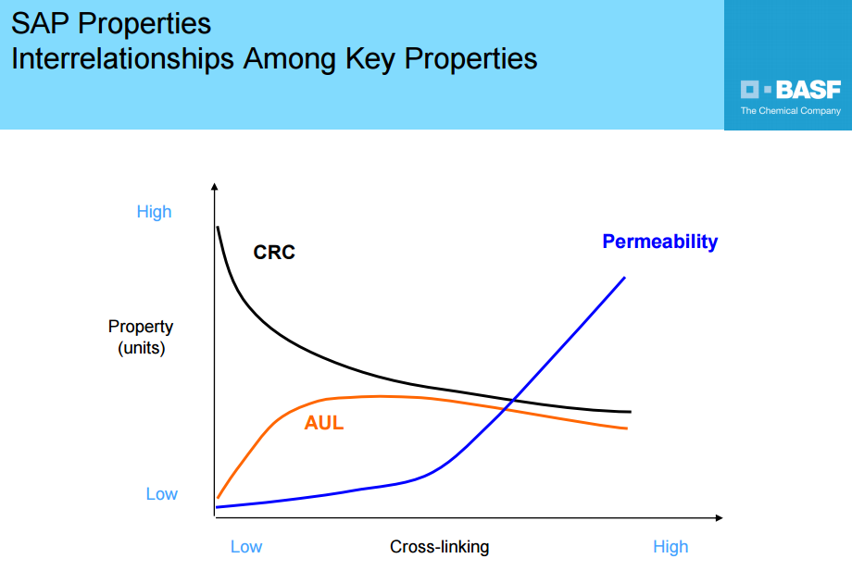

Appendix II: Simulink model
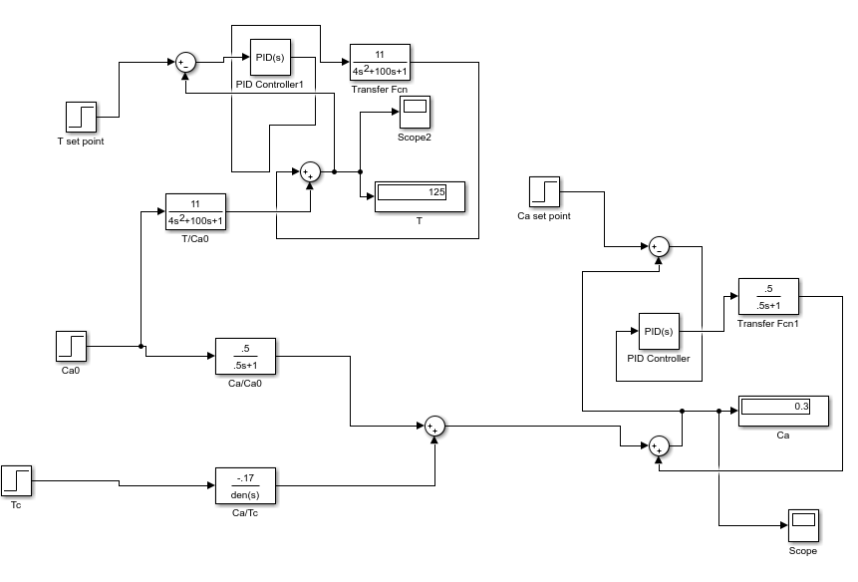

Appendix III: Temperature response graph

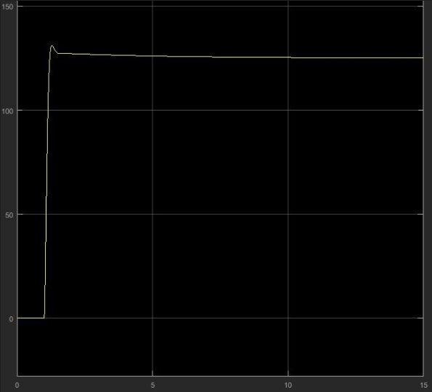

Appendix IV: Concentration response graph

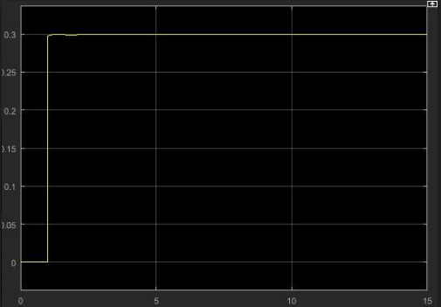

Appendix V: Concentration response graph
